n_TOF X17 May Logbook
May 2026 Beam Test — Logbook
EAR2, n_TOF, CERN • May 2026

Flammable Gas Planning
Prompt:
I am making a planning for using flammable gas at our beam test to send to CERN safety. I have a graphic timeline that shows all of this, but want to describe in detail the plan. Can you take what I have below and rewrite a nice report?

Info:
We plan to run a test at n_TOF EAR2 for the X17 experiment with flammable gas from Friday May 15 until Monday May 18. We will have one or two Micromegas detectors of 40x40cm active area and a 3cm gas volume. It is not clear if the second detector will be ready in time for the test, so we will account for the possibility in the gas planning. We will arrive with the detectors on Friday May 8th, and begin testing with non-flammable gases until Friday May 15.

On the morning of Friday May 15, we plan to switch to flammable Neon/Isobutane 95%/5%. Prior to doing so, we will install our detector(s) in place on the beam line and begin flushing with pure argon, while we begin working to install the necessary components for running flammable gas. We can conduct a leak test with the pure argon as it flushes. If we have two detectors available, the gas will be run in series through the two detectors before going to the exhaust in the EAR2 area. We will allocate the entire morning to setting up the detectors for using the neon/isobutane, with the option of continuing after lunch until the end of the day. Once the detectors are cleared for operation, we will switch from pure argon to the neon/isobunate mix. We will close the area and allow this to flush for a few hours while taking a monitoring run. Once flushed, we will begin taking measurements overnight, potentially entering the area to replace the sample on the neutron beam.

We will take data overnight and into Saturday morning, May 16th. During the day, we may run some tests that require us to access the area and make adjustments to the detector electronics, but no change to the gas volume or gas systems will be necessary. We may also change the sample on the beam.

We will again take data overnight and into Sunday morning. On Sunday, if we only have one detector we may want to remove the detector from the beam and make an adjustment to the drift window, which is located inside the gas volume. To do this safely, we would flush the detector with pure argon for an hour beforehand to evacuate all isobutane. Once flushed, we would remove the detector from its position on-beam, leaving all other systems in place. Outside of the area in the rack room, we will open the detector volume, adjust the position of the internal drift window, and then re-seal the detector. We would then remount the detector on the beam and reconnect all systems. We would then flush with pure argon for an hour before switching back to neon/isobutane and flushing. Once flushed, we would take our final measurement overnight.

On Monday morning, we will flush with pure argon for an hour before entering the area and dismounting the detector along with the rest of the set-up.

Planning Info
Feb Saturation Curves with B4C and 30mm drift
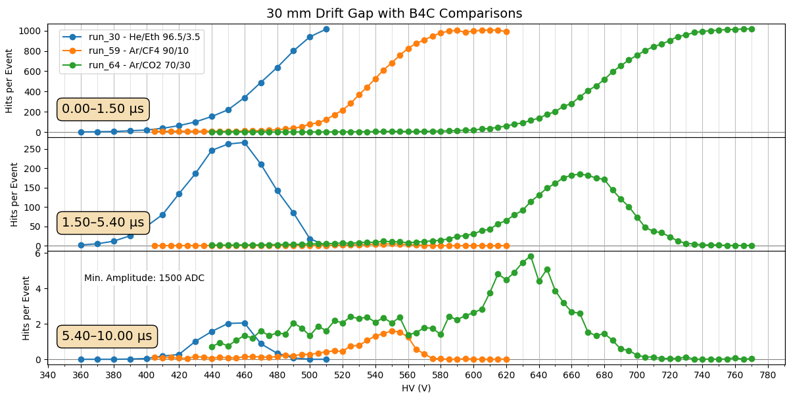
For beam saturation HV scan, run 5V steps, 5-10min each?
Ar/CF4 90/10 @ 30mm drift no aluminum: 480V - 620V → 30 points →5 hours at 10 min each
Ar/CF4 90/10 @ 30mm drift aluminum: 480V - 760V → 60 points →10 hours at 10 min each
Ar/CF4 90/10 @ 3mm drift no aluminum: 480V - 760 → 60 points → 10 hours

Saclay cosmic calibration cure with Helium/Ethane → 510V fully efficient
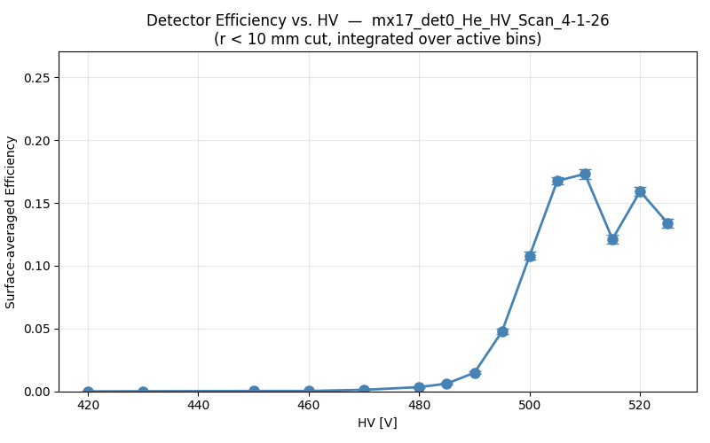

Helium Ethane Saturation from February.
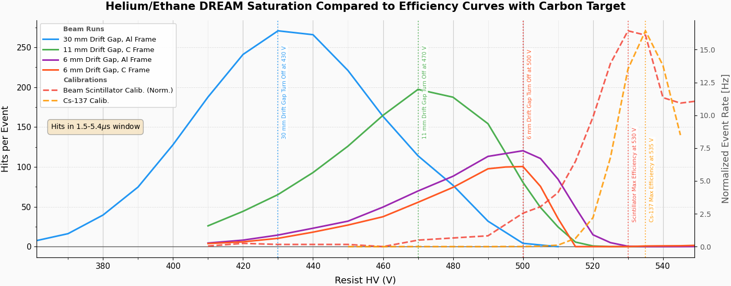
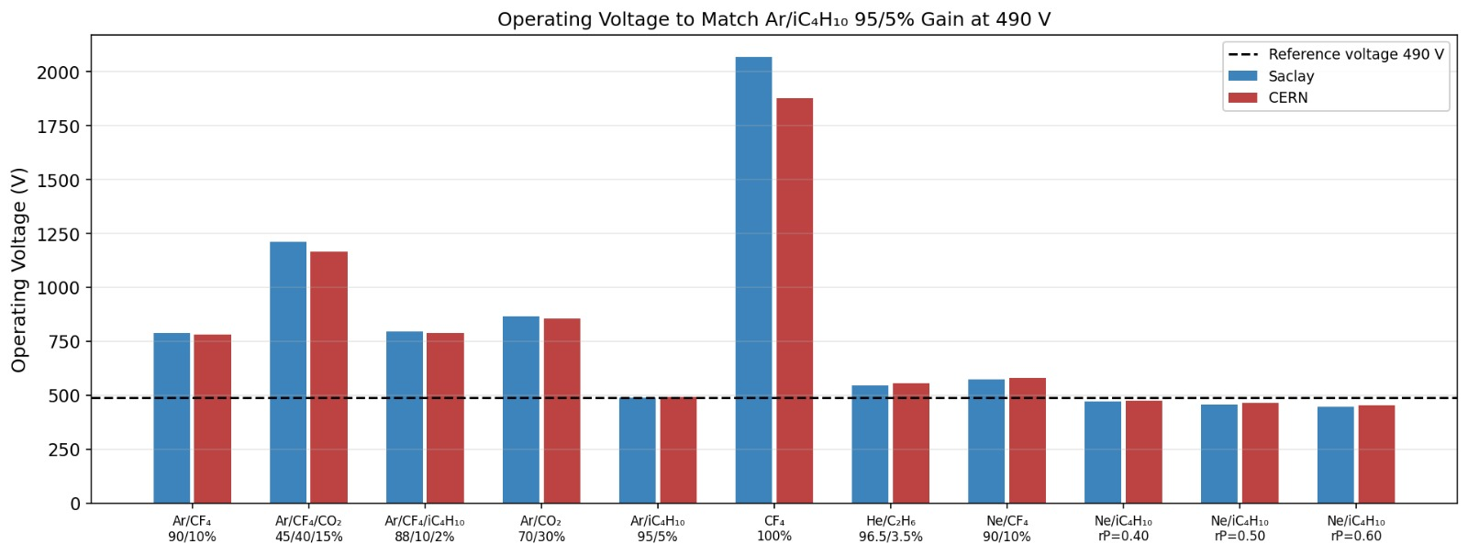
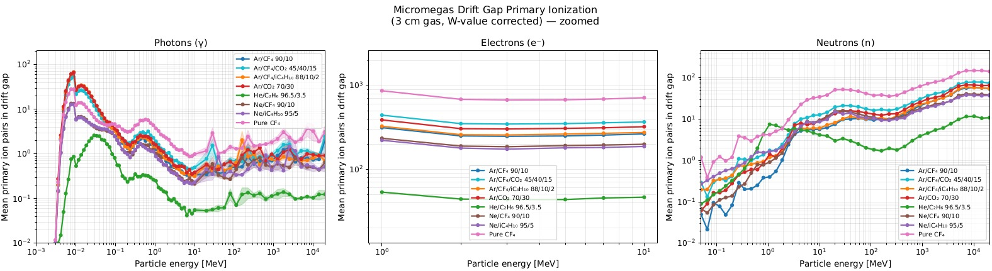
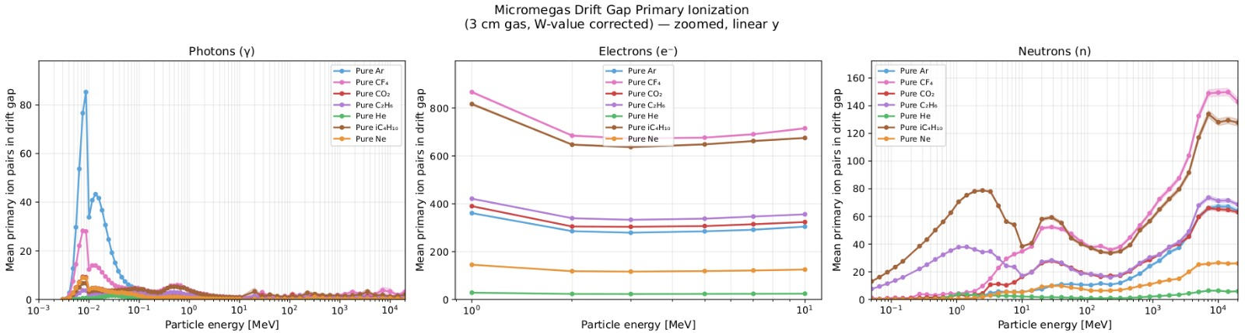
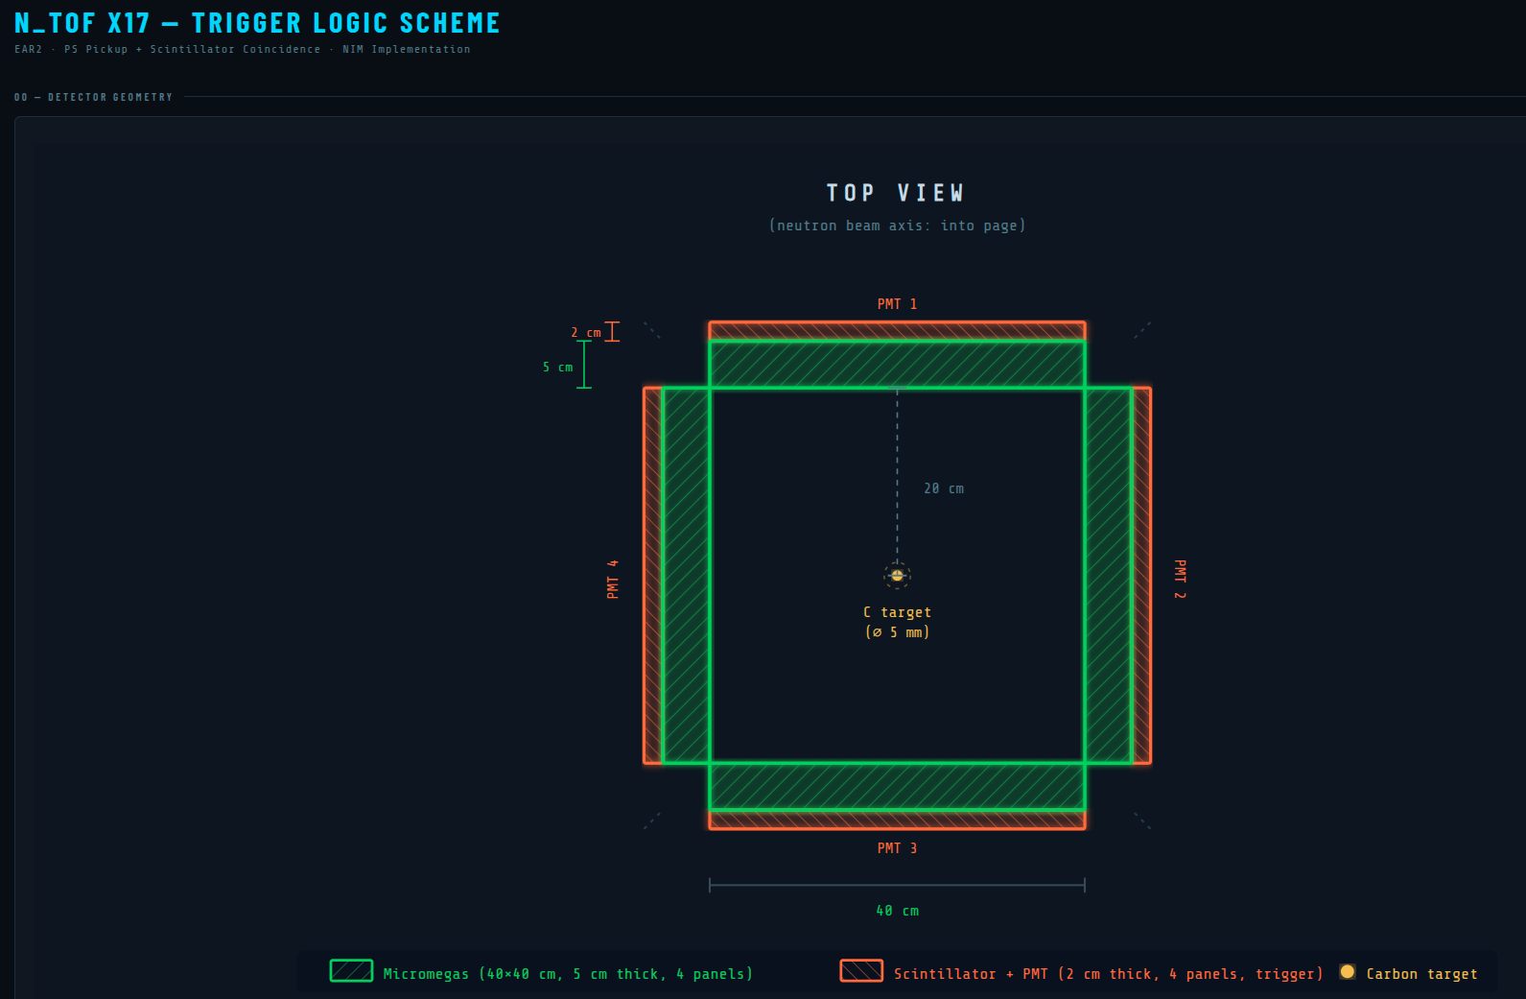
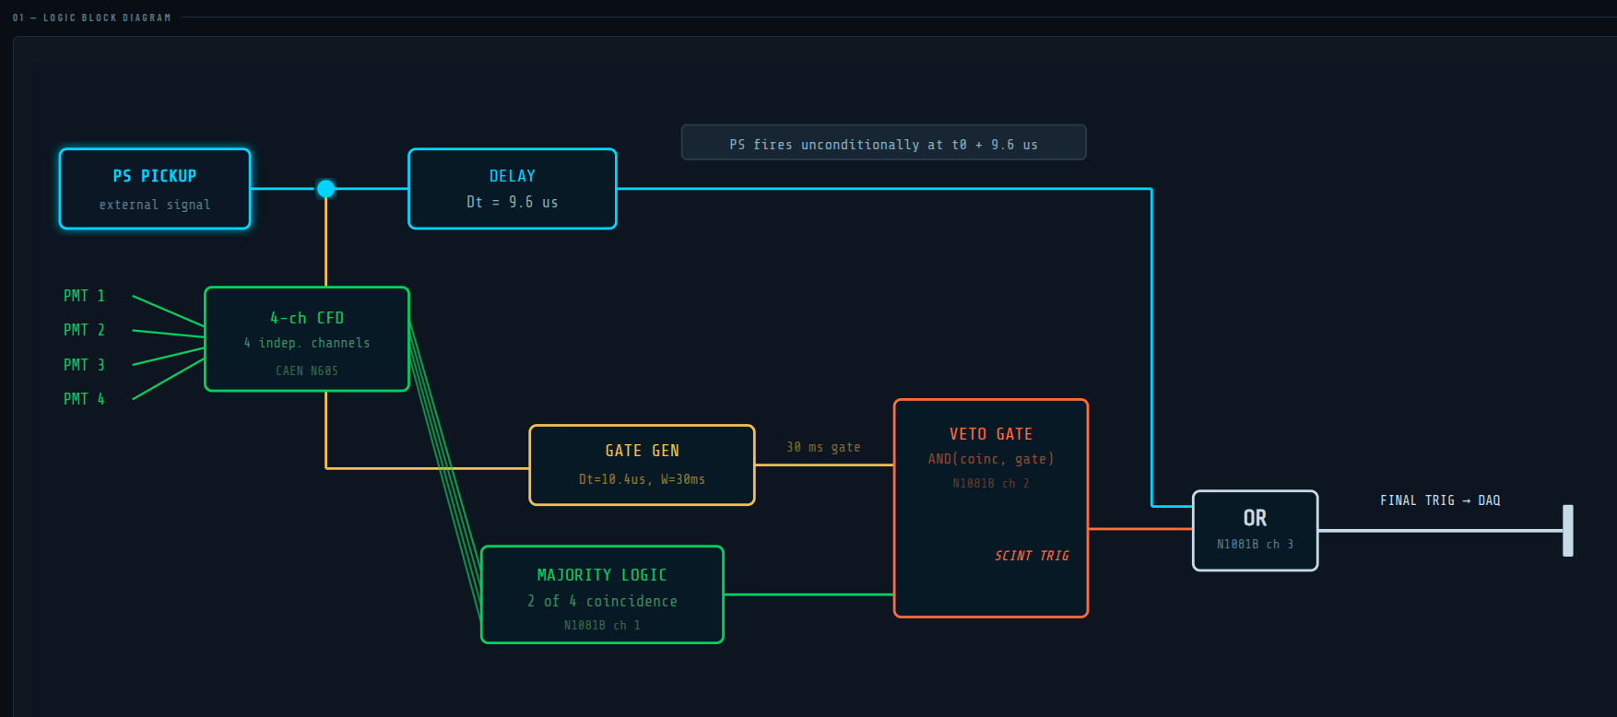
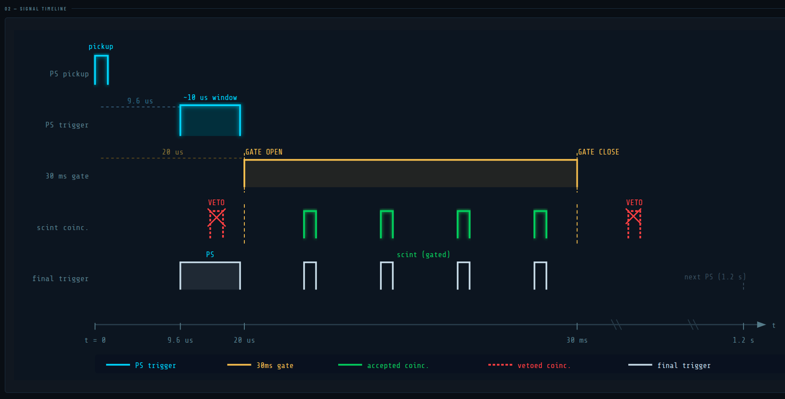
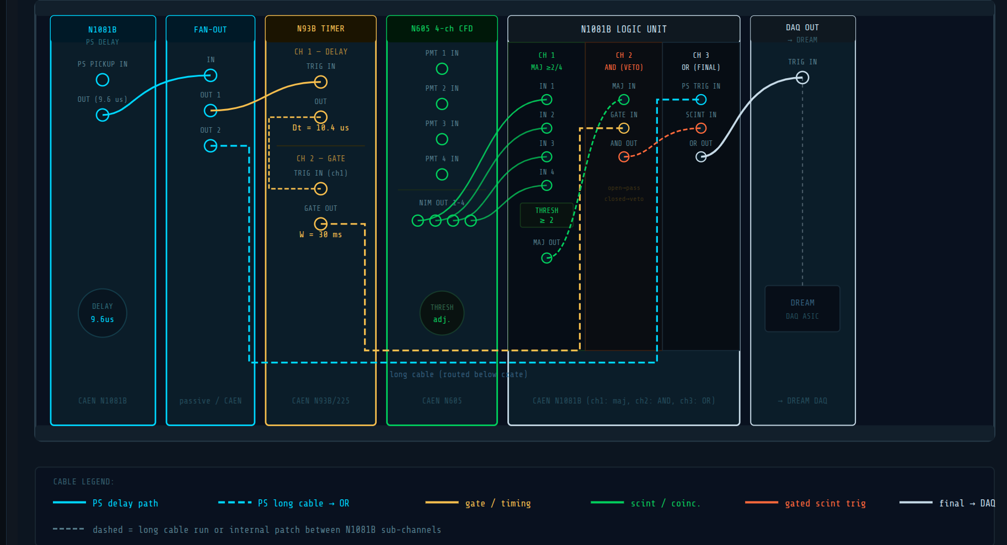

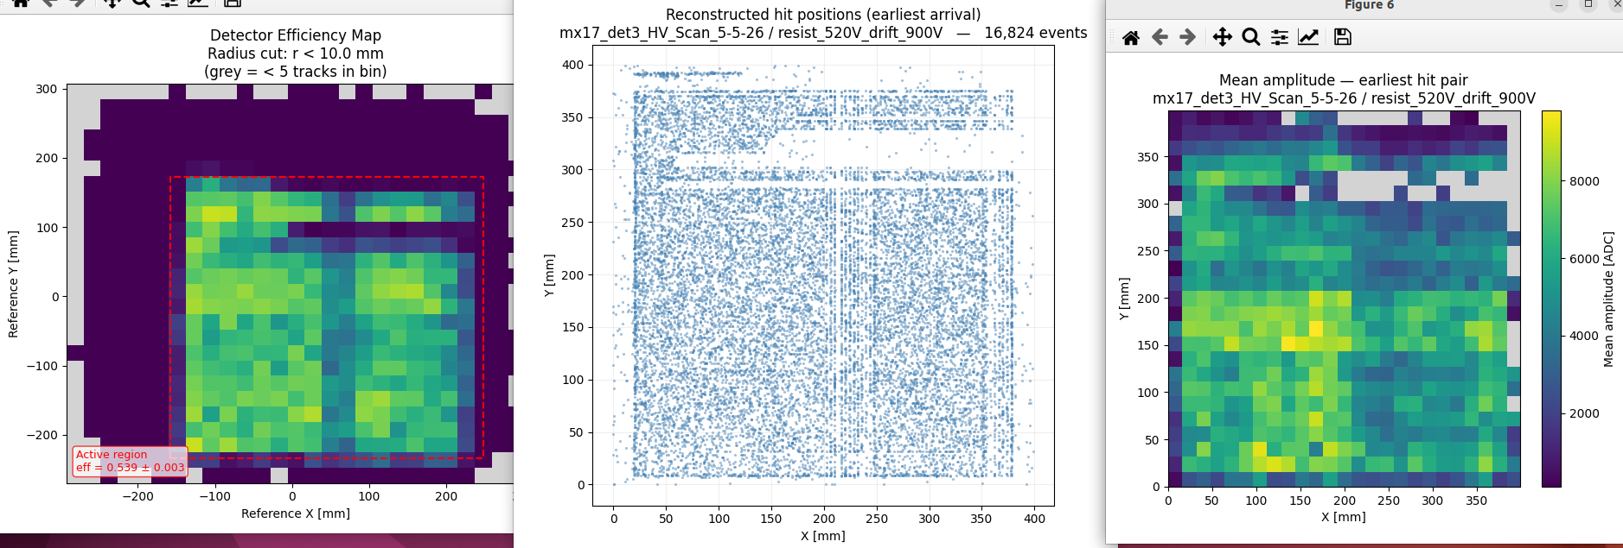
Test self trigger at some point during flush!
Run a drift scan at some point!

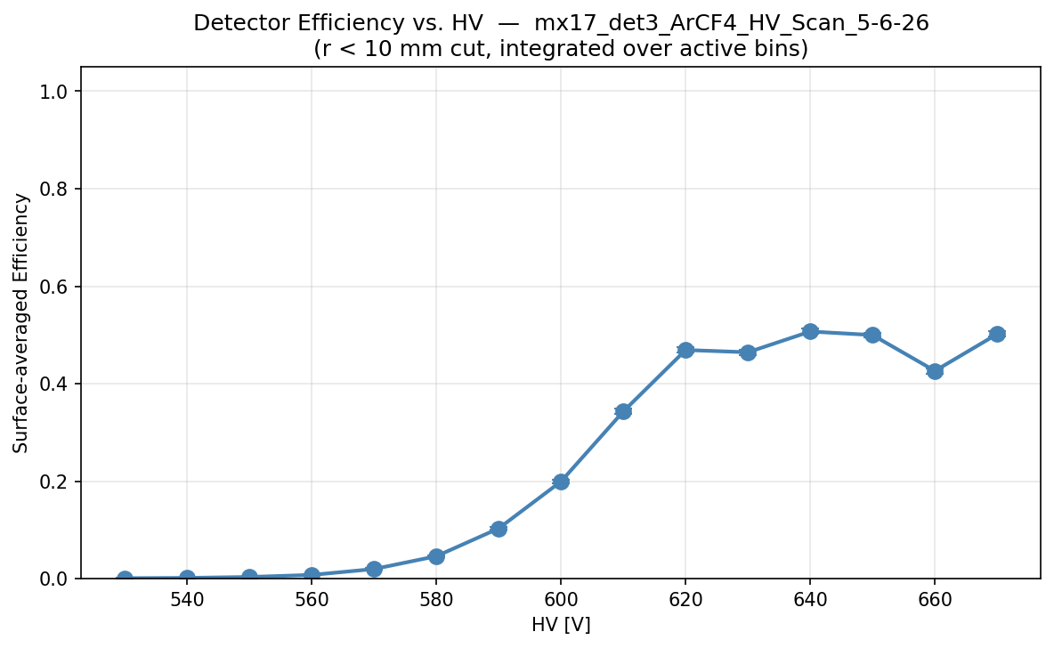

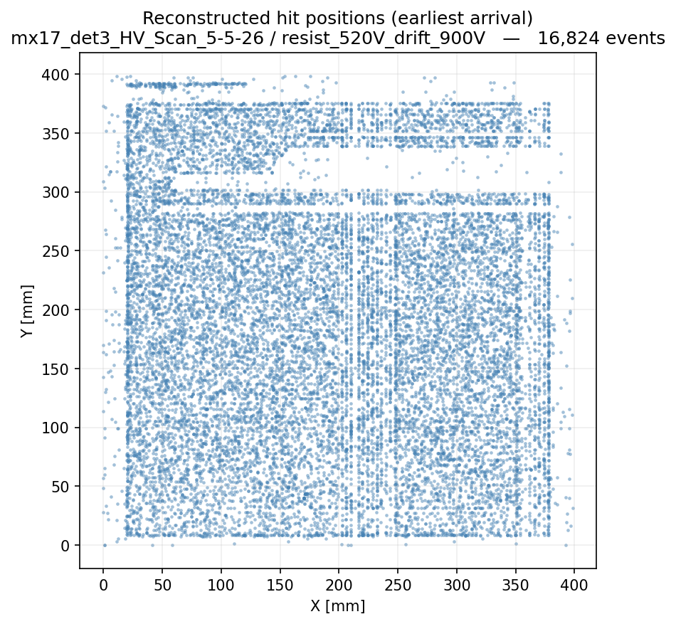
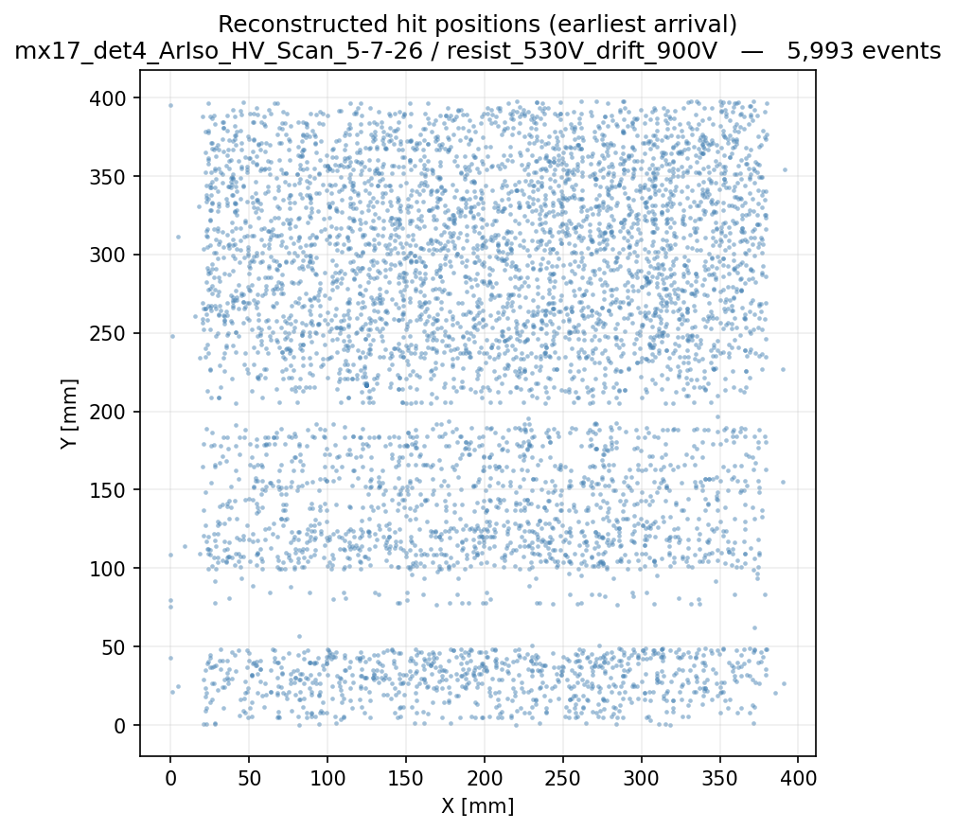

Friday May 6

Arrived at 3Pm to get set up
Learned that for DREAM need more voltage to run all the FEU. If too low (4.5V) fluctuations in current and communication problems when polling more than 1 FEU. At 4.7V things seem stable. Irakli was right, should have set up sense wire. Think we ended up needing 4.8V or 4.9V in the end.
DREAM Note: If communication issue randomly could be from low voltage fluctuations. Check stability of current.

Scintillators set up and coincidence at 7-8Hz. Trigger to Dream getting counts, looks good.

Stephan went to GDD and soldered all grounds to detectors and cards, success.

Got Argon/CO2 flowing through detectors at 6:10Pm. Started at 70 bar on 50L bottle.

6:15PM set to 0.5 ln/hr, 6:30PM looked like it was still bubbling. 6:30PM set to max flow 10 ln/hr

6:35Pm heading to schuman.

7:00PM swapping readout cards on the two detectors. For cosmics we will have:
30mm drift (detector 3) with 4 M1 cards, full readout
3.6mm drift (detector 4) with 4 M2 cards, x2 multiplexing.

Top scintillator A -1300V Card 8 channel 0
Bottom scintillator B -1300V Card 8 channel 1

8:10PM going to dinner, finish last two M2 cards after. 8ln/h on detectors.

9:00Pm back and finishing the rest of the cards. Not enough M2 nuts, so only 6 of 8 screws on each card.

9:50PM Putting HV. 800V on det 3 discharged.
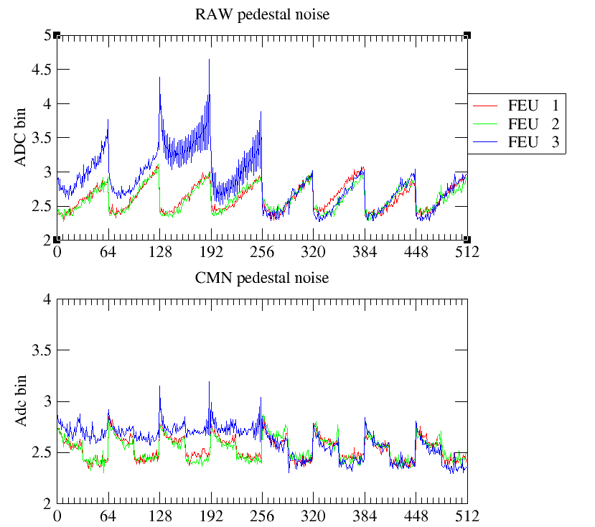
Pedestals of FEu 1,2,3 with only 4 cables in Feu 3 to nowhere

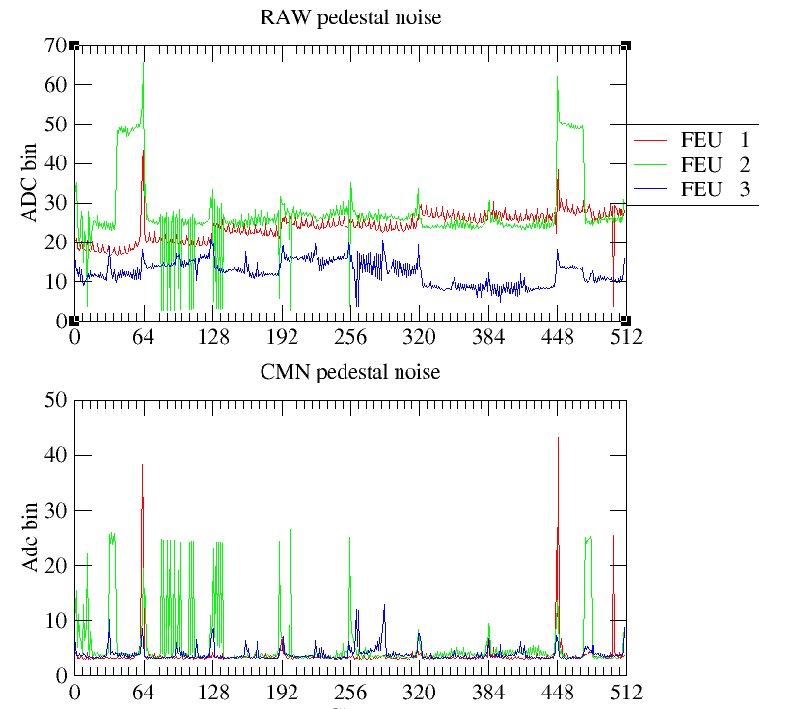
Everything plugged but HV off.

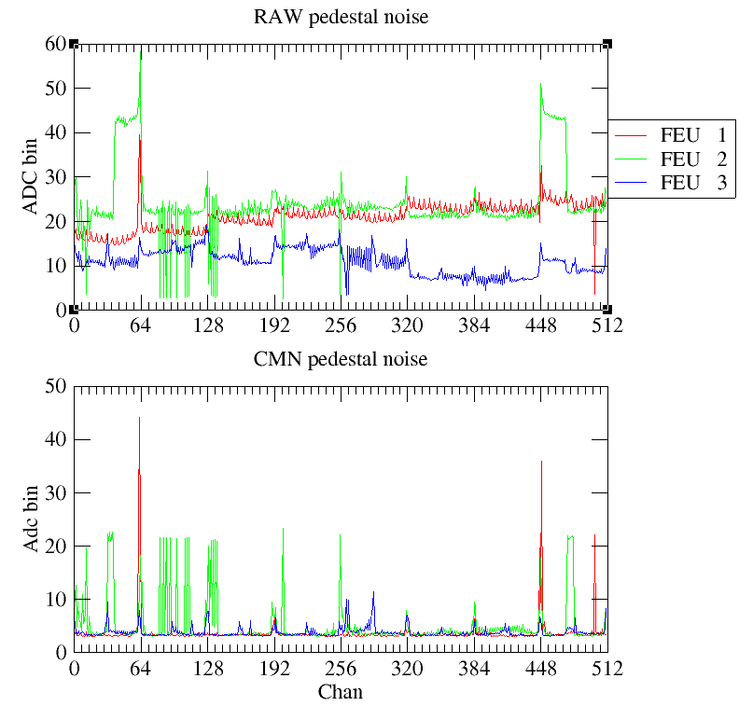
Same but after cleaning both sides of FEU 2 DREAMs 0 and 7 with alcohol. No real difference.

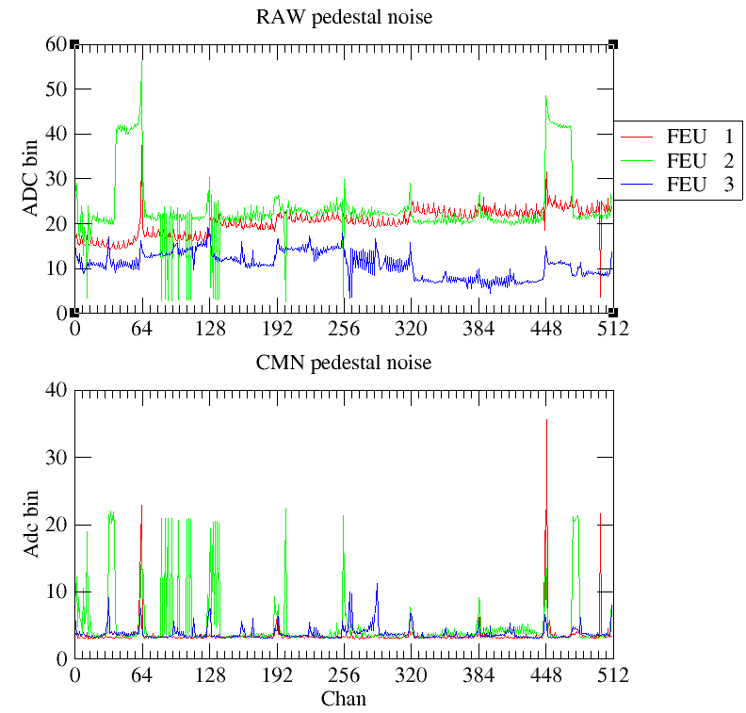
After turning on PMT HVs, looks the same

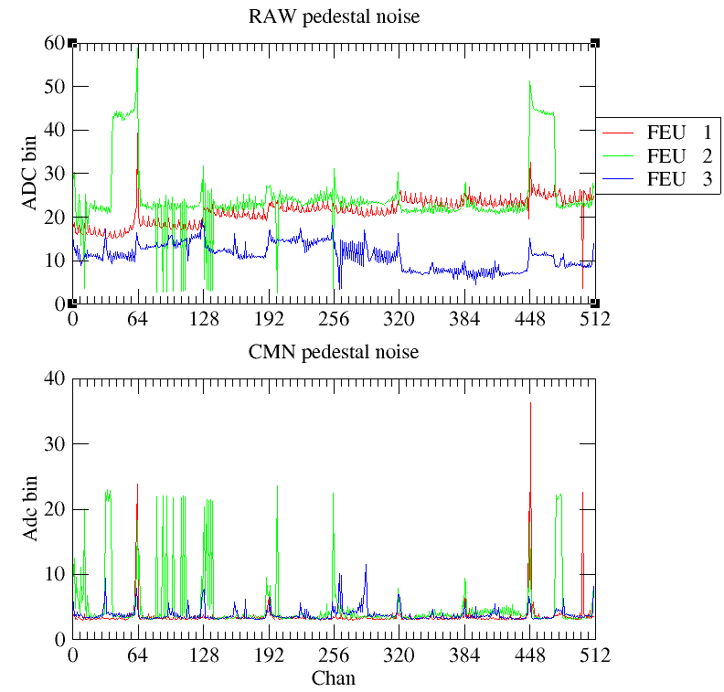
After turning on both drifts to -800V, same

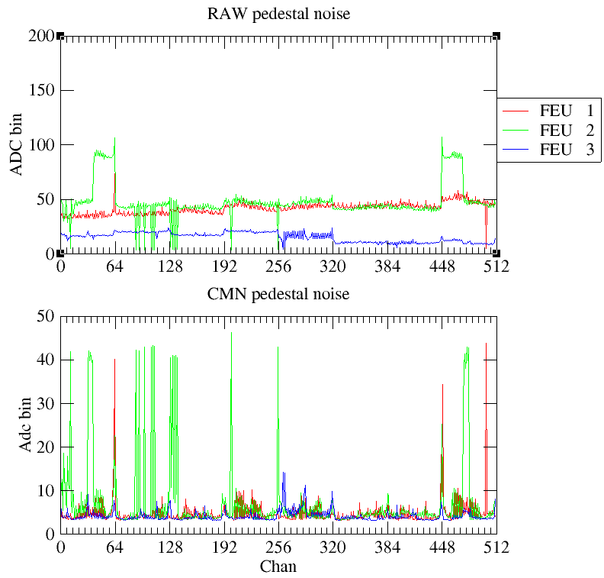
After turning on both resists to +700V on det 4 and +650V on det 3. Det 3 is seeing some discharges as it goes up.

Started operating at ~800V on both detectors, looking for signal. Timed in at around 24 latency (0x0014) with det 4 (M2 cards 3.6mm drift). Det 4 looks very reasonable. Det 3 with 30 mm drift is still discharging.
Det 4 mesh is grounded directly to the board. Det 3 mesh is floating, connected to ground via male/female connectors.
Seems like when mesh floats no current – maybe expected?
Stephan opening HV box on Det 3 to see if anything odd. Doesn’t look like it, everything grounded.

11:08PM gas flow lowered to 2 ln/h. Started HV scan before leaving.
Rotated detectors and setup to hang MMs over the edge of the PMTs for max coverage.
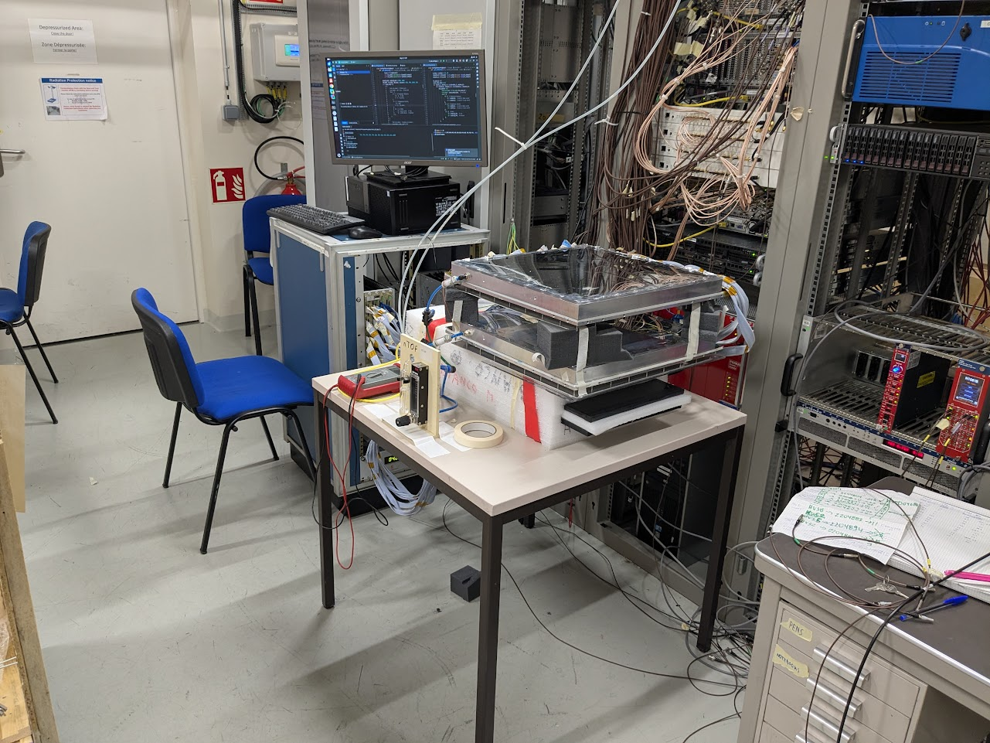
Saturday May 7

Run 1: Started a HV scan of det 4 with Ar/CO2, should be fully flushed. Coincidence trigger from scintillators. Was a problem – didn’t iterate the subrun name so all fdfs in the same subrun folder. Need to sort out but all data should be there,.

9:30AM Found that the scan ran but I didn’t iterate the subrun name in the run_config.py, so all fdfs in the same directory. Will have lost HV monitor data and need to manually separate later.

Run 2: Just a quick “run” to monitor detector 3 resist voltage/current as it ramps up. Looks like current slightly super-linear – not purely ohmic circuit. Sparked around 460V.

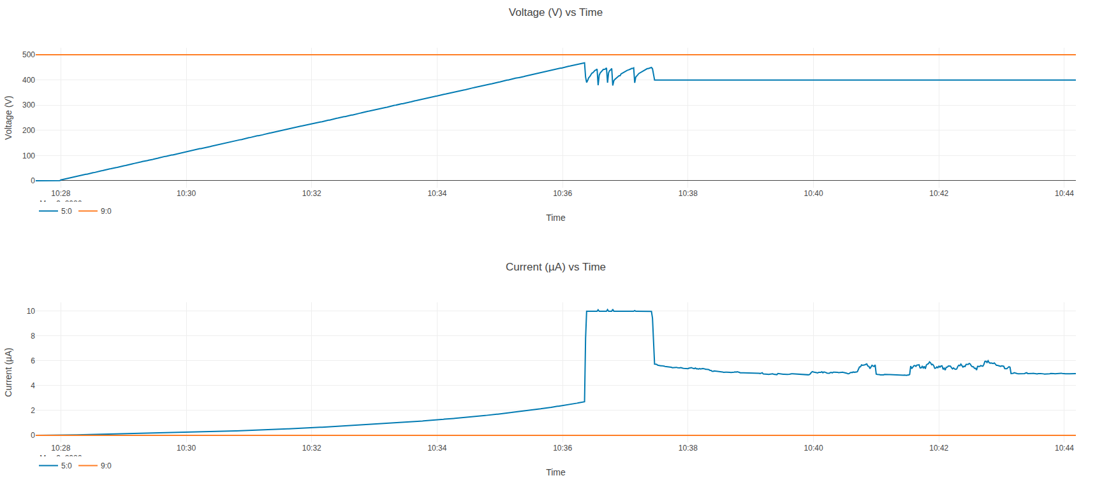

From pedestals of det3 with current no obvious discharge location:
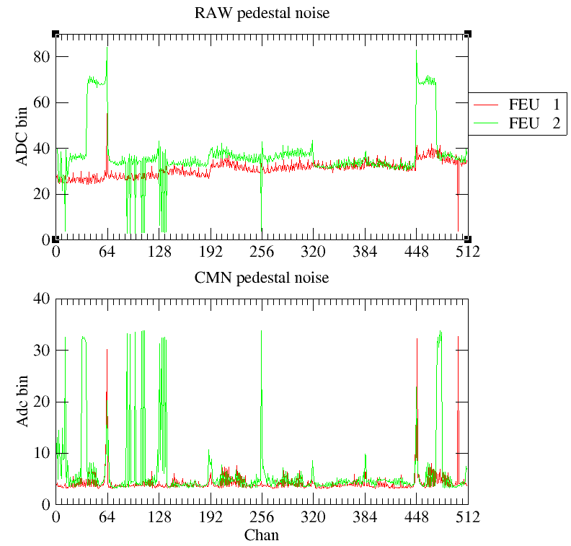
11:20AM all HV off and disconnected detector 3. Packing it for GDD. Don’t know what to run in cosmics while we’re gone. Will have to plan a bit and hopefully take a look at the data from last night to see if we can get a calibration curve.

3:00PM Just returned from GDD clean room with det 3. Stephan glued over problematic areas, was some kapton tape on the board. Seems that this may have worked, though detector still might be slightly unstable during ramp, should stay at 1V/s

Realized that the cosmic run from last night had latency of 1 instead of 24, so data garbage unfortunately. Will have to rerun today.

Plugged det 3 in series after det 4 and set flow rate to max (~20ln/h) for 30 min. Labeled the 16 2m cables.

3:30PM Back to 8ln/h, just finished plugging HV and Dream cables.

Pedestal after everything plugged but all HV off. Looks very similar to yesterday. The y half of det 4 is now higher, similar to det 3.
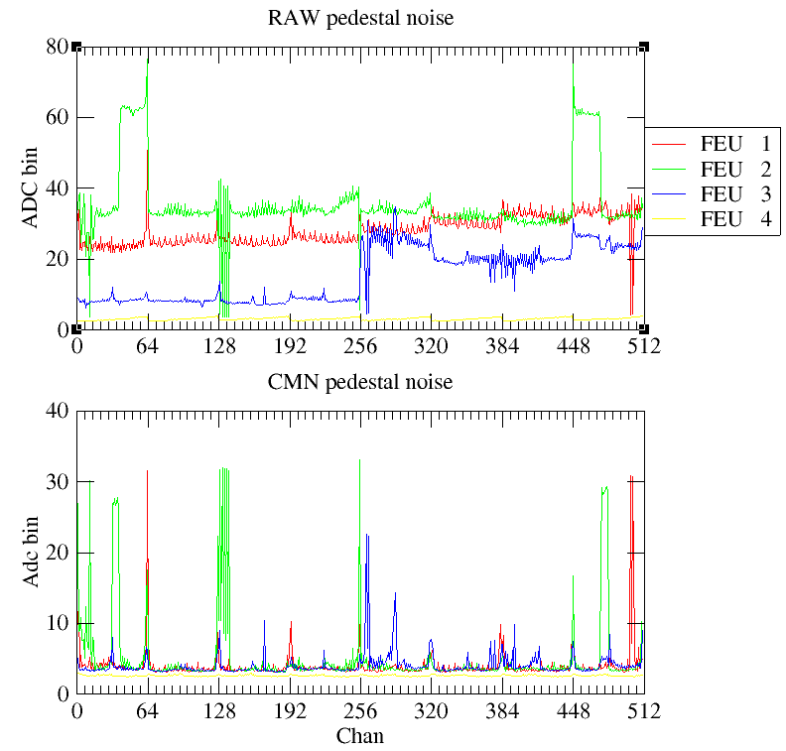
Ramped all HVs up, drifts at -500V. Det 4 resist at +850V, no problem ~145nA. Ramped det 3 in steps at 3V/s to 800V, discharged around 790V. Pulled back to 750V and stabilized. Went to +800V at 1V/s from there. Again some discharge at 790V but eventually got to 800V and stabilized, 240 nA.

Took pedestals again at voltage. Noise amplified
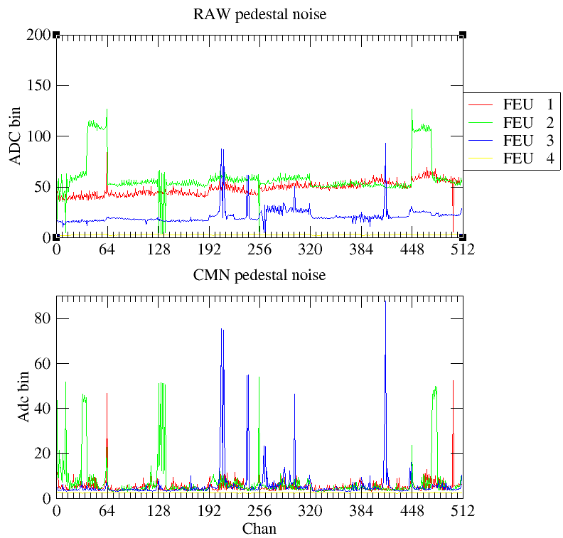

4:05PM Going back to 8ln/hr on gas flow.
Looked at signals, seemed reasonable for det 4 but det 3 not seeing as many as I would expect or what would look like micro-TPC tracks.

Run 3: Set for cosmics in Argon/CO2. Detector 3 and 4 both in, with large voltage steps of -20V with 10 mins each run, 10 steps. Started Detector 4 at +890V and Detector 3 at +840V

Run 4: More cosmics in Argon/CO2. Pushed Detector 3 up to +875V and started Detector 4 at +875V. 15 minute runs in steps of -10V.

11:40 PM changed to Ar/CF4 90/10. Flushed at +20ln/h for a minute or two then leaving at 8ln/h overnight. Turns out it was closer to 3ln/h overnight.
Sunday May 10

Run 5: Run for gas change from Ar/CO2 into Ar/CF4. 6 hours gas change run then HV scan at around 6AM, 10 minutes each starting at a safe 660V resist for both detectors.

10:30 AM Arrived and checked the detectors, things seemed fine.

11:00 AM Checked the gas flow and found it was 3ln/h instead of the 8ln/h we wanted. Put back to 8 ln/h.

Run 6: Started new HV scan at higher voltages, starting both detectors from +730V with steps of -10V. Realized that the Ar/CF4 gas bottle was running out during this run!

12:50PM Went to gas rack and found gas pressure was at 0 bar. Looks like we’re somehow out of Ar/CF4.

Run 7: HV scan on new bottle of Ar/CF4, probably transient so will run new scan after lunch.

1:00PM Realized we were using the old empty bottle of Ar/CF4 from Feb. The 50 bar we saw last night must have been residual from Ar/CO2. Used the rest of the Ar/CF4 bottle over night. Found the new bottle from EAR1 in the other rack and connected it. About 70 bar. Setting from 8ln/h and adding two turns, probably between 10-20 ln/hr. Leave like this till after lunch.

2:00PM checked the gas and no change to outside pressure at our flow rate, still around 70 bar, so left at high flow. Will have to rerun a scan in run 8 to see if there is change.

4:00PM while running last point of Run 7 lowered gas flow from ~20ln/h to 3ln/h
4:05PM still bubbling well, lowered 2 ln/h
4:20PM gas bottle still at 70 bar. 16 bubbles in 10 seconds, seems stable enough. Will ramp HVs up and start new HV scan.
4:30PM Ramped resist HVs to 765V, det 3 sparked quite a lot on the way up but made it.

Run 8: Cosmic HV scan with Ar/CF4. Started both detectors at +765V with 10 min runs dropping in steps of -10V. Gas flow was lowered to 2ln/h, hopefully stable.

Detector 3 seems to have a good turn on at around 630V as expected from Saclay. Restart the scan before dinner

Run 9: Cosmic HV scan with Ar/CF4. Started both detectors at +670V with 10 min runs dropping in steps of -10V. Gas flow still at 2ln/h.

Ok seems reasonable but set for overnight scans.

Run 10: Overnight cosmic HV scan with Ar/CF4. Some more complicated structure. Started both detectors at +675V with 15 min runs dropping in steps of -5V for 20 steps for a good, fine scan. Then, run for 6 hours at +635V (I think?) which should be beginning of plateau. Then do another quick scan over the turn on curve from +675V for 10 min in steps of -10V for 10 steps (I think?). Gas flow still at 2ln/h.
Monday May 11

9:10AM Entered area and run had already ended. Turned off all HV and stopped gas flow from our flow rate control. DAQ GUI looked like the processing was still going, should check. Somehow processing got stuck, weird. When I restarted it ran through fine.
Brought both detectors to GDD clean room and opened. Swapped the gas chambers + drifts, leaving the board/cards/and everything below in place. Had issue when placing the adjustable drift in detector 3 – placed in wrong orientation when sticking feet. Had to remove feet and restick, but just used the same double faced tape. While 3 of 4 feet looked to line up pretty well, the fourth was barley on the tape. Worried the drift window will fall inside the detector, though seemed to have survive the mounting. When closing, had issue with current on det 4 drift, the nominal 30mm. Found that it occurred when tightening the corner screw by the HV. Kapton taped the area and seemed to be better, though not perfect.

1:00PM Detectors in rack room running Ar/CF4 at max flow ~20ln/h
2:20PM Reducing flow to 8ln/h. Removing detector 4 for mechanics testing
~3:00PM Brought rack in to area and start putting detectors on
~3:40PM Detectors back in gas
3:50PM Moving DAQ into area
4:55PM Everything mounted and DAQ working. Disconnected FEU 4 manually while it was on, not a great idea. Pulled the LV cable and put it in rack room since we won’t use it.

Pedestal before removing FEU 4, nothing plugged in
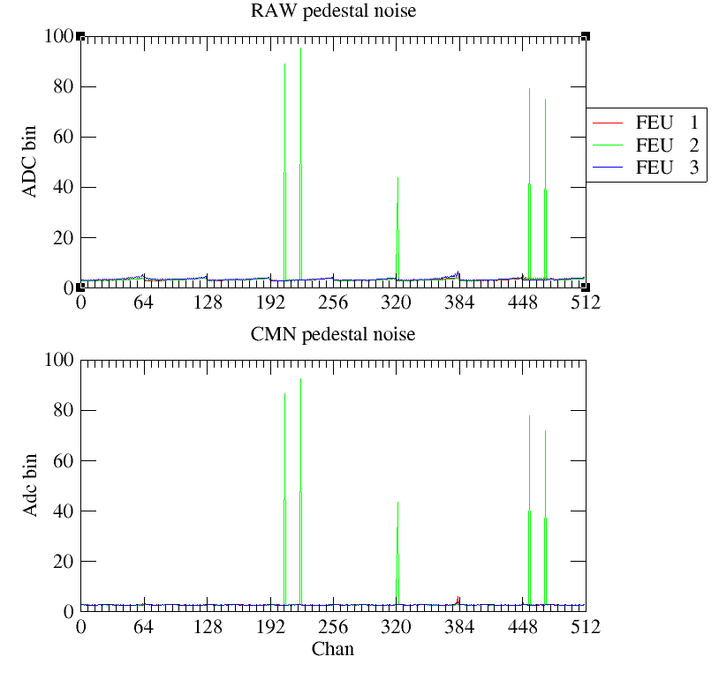
Removed FEU 4 and moved the plugged cables on side of rack, touching nothing
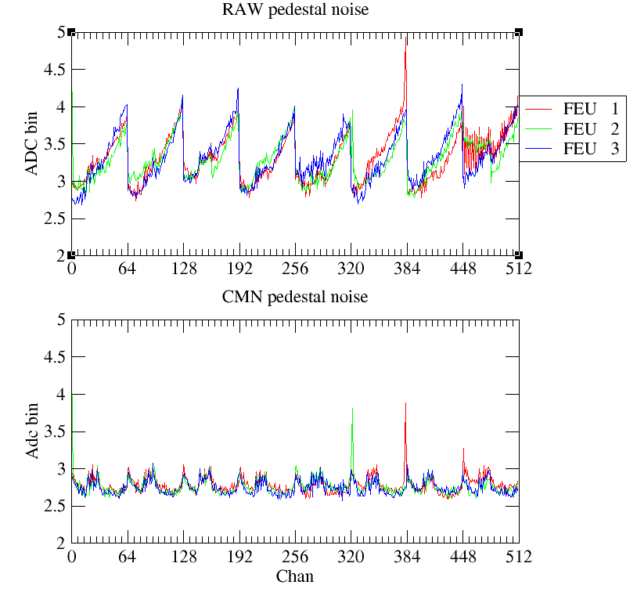
5:30PM Finished routing and plugging HV, dream cables for MMs and HV, BNC for scintillators.
Pedestals with all cables plugged but HV off.
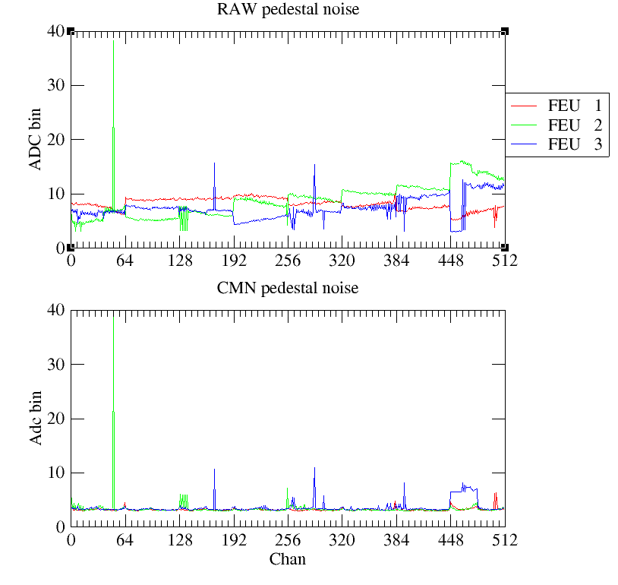
Mesh on det 3 was floating. Grounding now and checking again. Ah so much worse with mesh grounded???
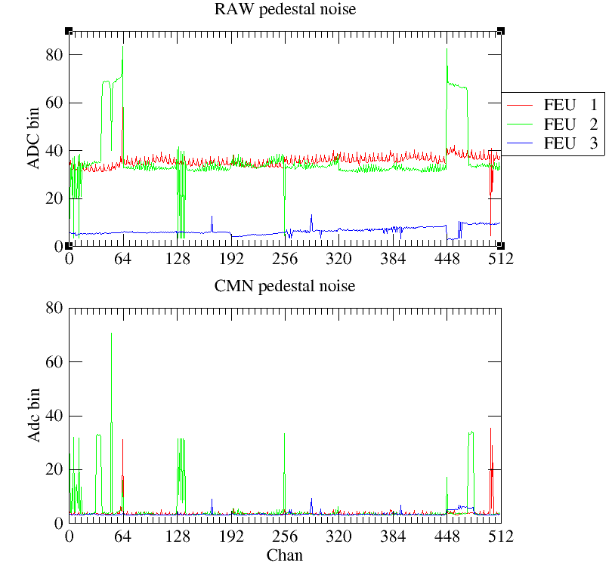
Removed mesh from ground, pedestals back to good:
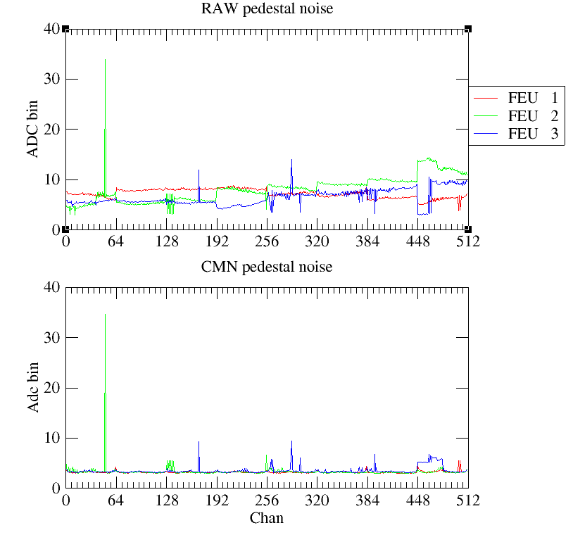
Ground to detector instead of external braid.
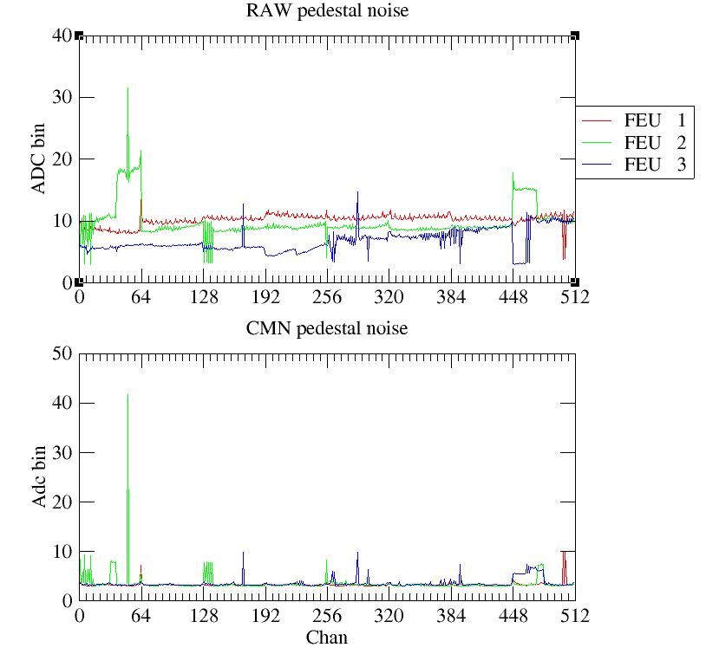
Clipped mesh cable to ground on detector. Seemed that good ground of mesh to detector is necessary to reduce noise.
Applied HV. On drift, detector 4 (with nominal 30mm drift) only goes to around 900V before there is current, pretty consistently.
Run pedestals with HV on, +400V on both resists and -800V on drift of det 4 and -1000V on drift of det 3.
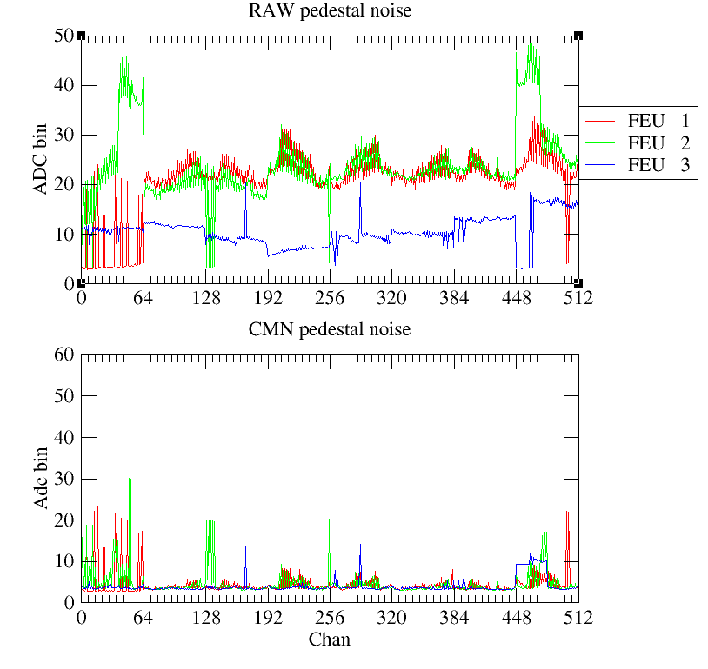
Seeing noise above when mesh not plugged directly to board ground with paperclip and blue cable.

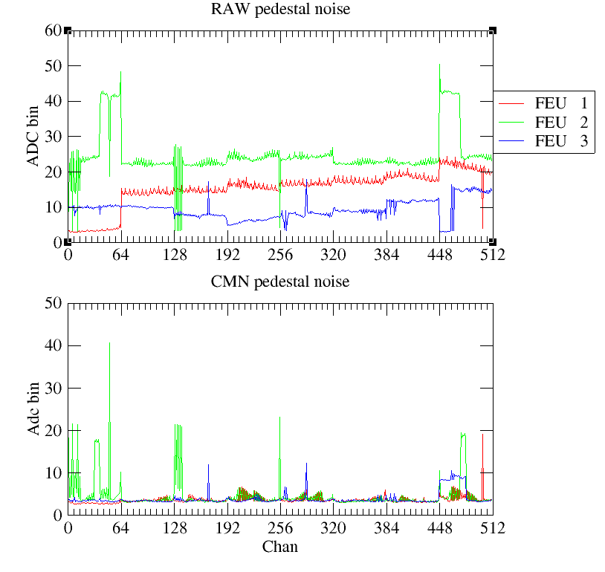
Returns somewhat to where it was when blue cable put back. Still worse than before, assuming HV.
To check FEU 2 spikes in DREAMs 0 and 7, swapped DREAM 7 and DREAM 6. Spike changed position, meaning it’s either the M1 board or the detector producing the noise, not the FEU. Could swap M1 boards to check but would take time.
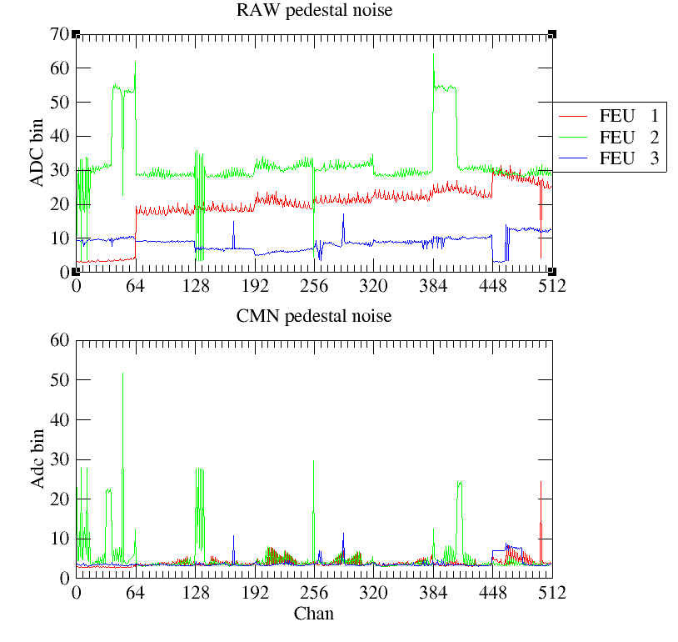
8:00PM Set up trigger, seems to be ok

Don’t know what happened but Resist HV was off, so don’t know if previous pedestals were taken with Resist HV or not.
Took drift HV off and got these
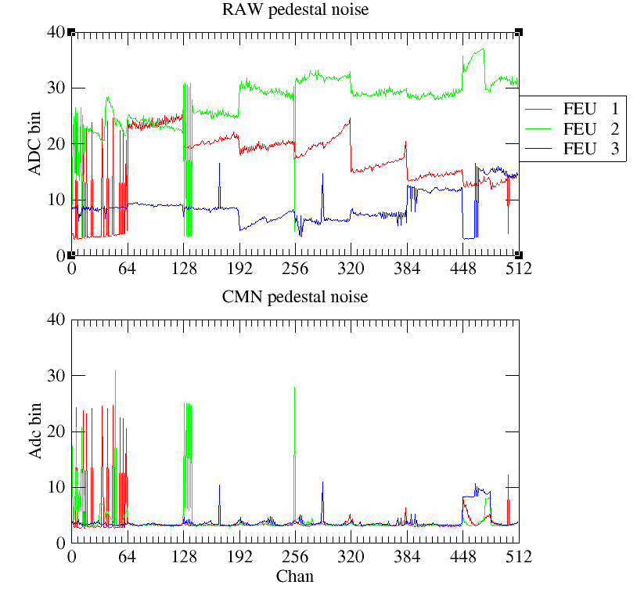
~8:10PM Closed the area and asked for beam.

Had both detectors mounted and ready to go. Detector 3 (16mm drift and decent efficiency in cosmic bench) had the charge-injector attached to the floating mesh. When powered, this circuit should be grounding the mesh. It sounds as if the box was powered on when we left the area, so mesh should be grounded. Unclear if the thing is actually injecting charge onto the drift?

Gas flow was around 7 ln/h when leaving area.

~8:40PM Looked like some issues with beam so we went to eat. Message that there was a problem so everyone left.

10:30 PM Looks like beam is back? At least getting triggers. Starting a run

Run 11: First beam test run with Ar/CF4. Started both detectors with -800V on drifts and +635V on resists, should be start of efficiency. Just made 20 3 hour runs and plan to stop manually and analyze. Gas flow at ~7ln/h.

A lot of very strange

Run 12: First beam test run with Ar/CF4. Started both detectors with -800V on drifts and +635V on resists, should be start of efficiency. Just made 20 3 hour runs and plan to stop manually and analyze. Gas flow at ~7ln/h.

Tuesday May 12

Pass
11:20AM Prepping for access. Can’t get noise

11:30AM Access for noise tests

After beam off and all HV at operating (635V), maybe some beam?:
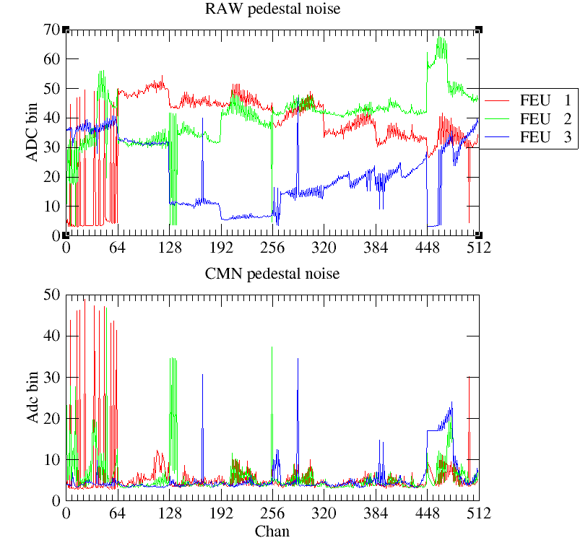
As door opening:
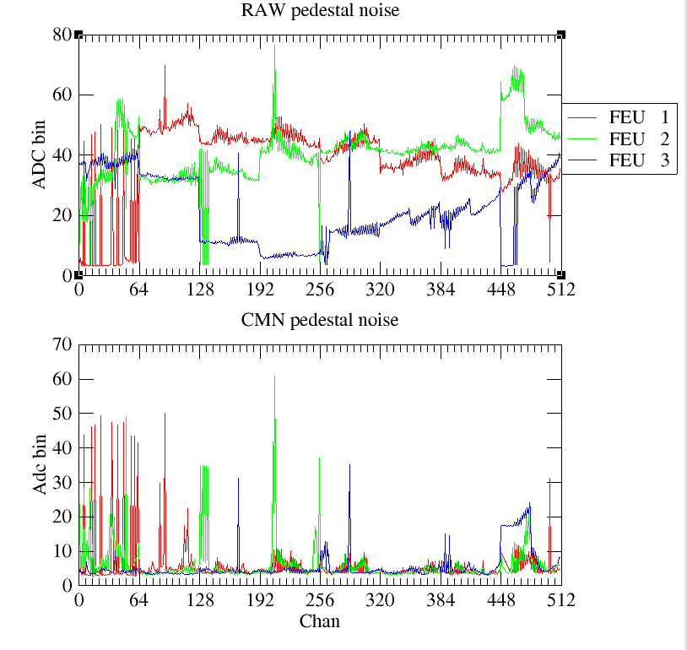
With blue grounding wire to mesh:

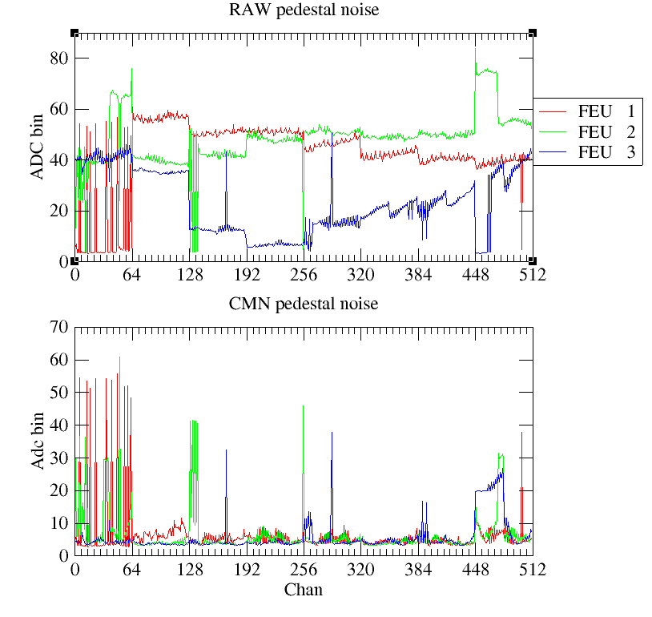
After box power off, somehow worse. Could have been Stephan and Pino putting rochelle on front of rack:
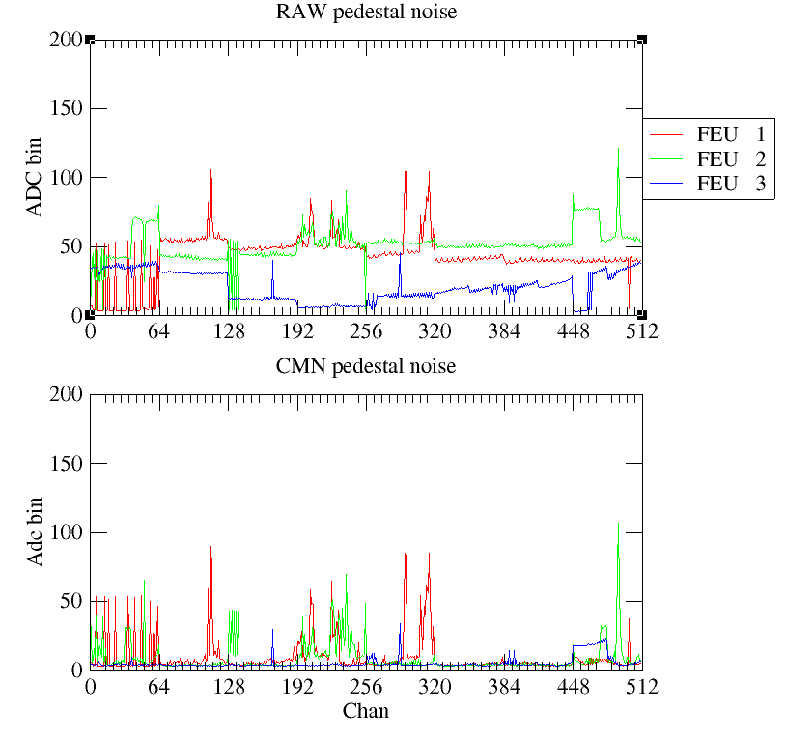

Added shielding around det 3 FEU 2 (y) cards.
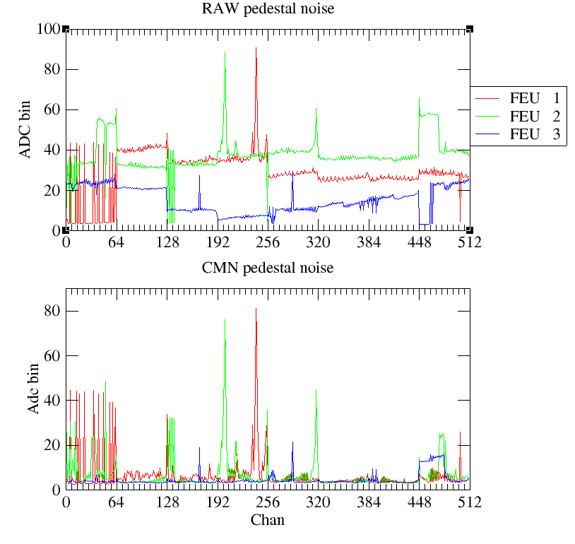
Added shielding to the other cards FEU 1:
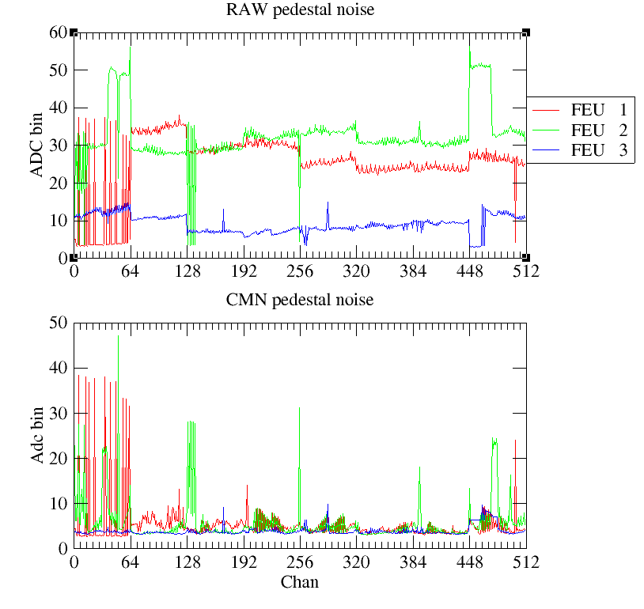

~12:10PM Closed area and I got a pedestal off before beam

Run 13: Quick run with no hv control to see quickly what we have. Start detectors at drift of -500V, resists at +600V – subruns 0, 1, 2. Dropped to +400V for subruns 3 and most of 4. Subrun 5 back at +600V.

Noise still terrible on both detectors even with box totally disconnected and unpowered.
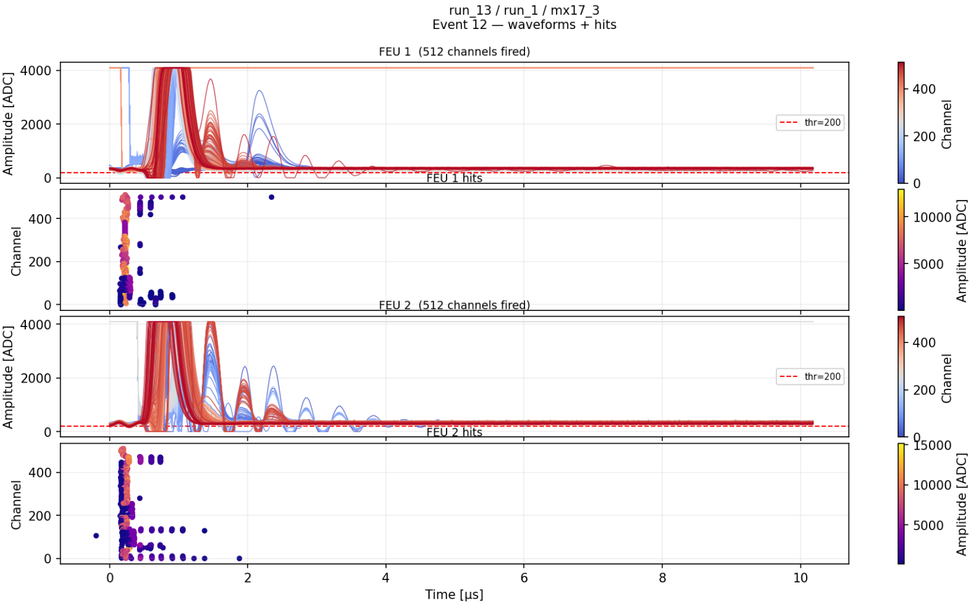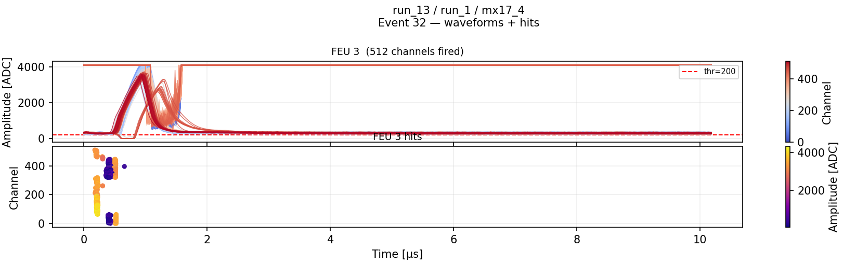

Run 14: Set for quick HV scan over lunch with both detectors in Ar/CF4 90/10%. Drifts at -800V, start resists at +635V and take 5 minute steps of - 5V. Somehow didn’t go?!

2:15PM Testing the noise generator with Simone, turned off PMTs in process.

2:30PM Will enter for electrical safety check. Also plan to disconnect the lemo board dream cable from FEU, hoping this is somehow bringing current or noise? I think Pierfranceso will reconnect box.

~3:45PM Safety/gas check finally over, seemed ok. Found that the aluminum bars were not conductive, so half our structure wasn’t grounded, need to deal with that.

Run 15: Quick look without HV control. Set to -800V drift +635 resist for subruns 0, 1, 2. +500V resist for subruns 3, 4. Voltage on resists killed at the end.

Run 16: Quick look without HV control. Set to 0V drift +500 resist for subruns 0, 1, 2. +500V resist for subruns 3, 4. Voltage on resists killed at the end.

7:10PM We have become suspicious of the LV causing the 4096 saturation problem. Switched the TCM plus FEUs 2 and 3 onto the 5V CPU power supply that was used for medicaplus. Will see how it goes.

Took pedestals with drift HVs at -800V and resists at +600V. FEU1 DREAM 1 (first) is plugged to the FEU but floating on the other side.
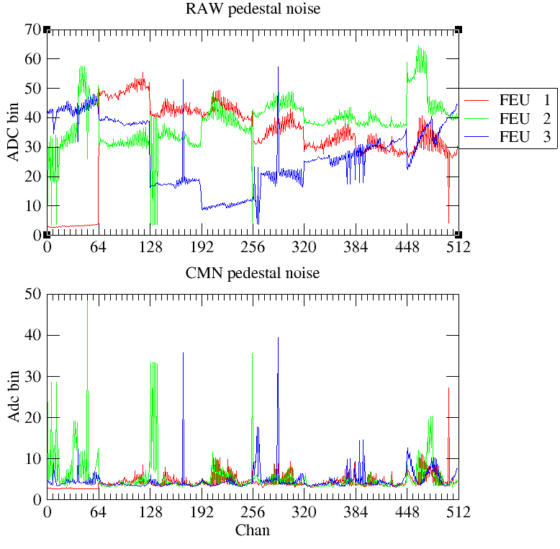
Another one now that everyone left
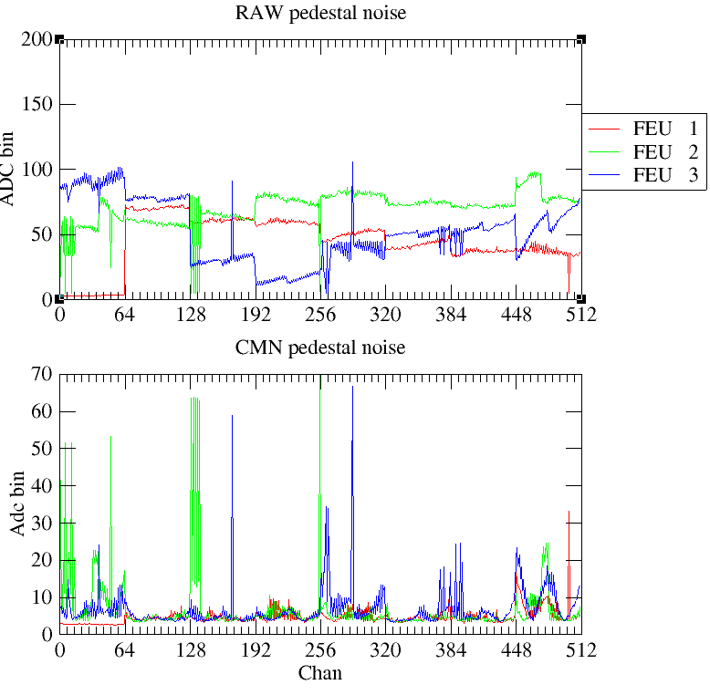

Run 17: Quick look without HV control. Drifts at -800V, resists at +600V, ramping for subrun 0. Subruns 1, 2 at +600V. Subrun 3 ramp to +635V. Subrun 4, at +635V

9:50PM Entered to increase slope of mesh circuit and put ~2mm aluminum plate on detector 4

Run 18: Quick look without HV control. Drifts at -800V, resists at +635V for subruns 0, 1, 2, 3…

Looks like fewer signals with the increased slope of the mesh injection. Also looking like with the aluminum plate we’re still saturated on det 4.

Solved some issues with the HV control. Looks like there might be a max number of connections? Closed geco on the mx machine and things worked. Was the issue of the monitor + hv set, I guess?

Run 19: Overnight HV Scan

Wednesday May 13

Run 20: Long single run at +635V on resist, -800V drift to see if eventually all dreams get stuck at 4096.

9:00AM Nicolas arrived and set up the flammable gas detectors. We worked on the grounding, all legs of the frame should be well grounded now, just unscrewed/rescrewed the Ls very tight.

11:30AM Access while beam is down. Will run noise tests.

Run 21: Noise tests +635V on resist, -800V drift.
Subrun 0: Trigger test garbage.
Subrun 1: 200V on noise generator. Will have to see if we see it on detector.
Subrun 2: Power off, nothing

Crazy noise and even saturation

Run 22: Noise tests +400V on resist, -800V drift.
Subrun 0: 200V on noise generator, triggering now only on discharge, high amplitude.
Subrun 1: Garbage
Subrun 2: No noise-generator. Generate trigger manually on oscilloscope antenna by touching it.
Subrun 3: Garbage
Subrun 4: All HV off to detectors
Subrun 5: Garbage
Subrun 6: Disconnected Det 4 HV cables → Didn’t make a difference
Subrun 7: Garbage
Subrun 8:

Trying to test Irakli suggestion of 224 samples, having trouble but got in Run 25.

Run 23: All MM HV off, HV unplugged on det 4. Sample period the same at 20ns, set number of samples 510 per Irakli suggestion.
Subrun 0: Good
Subrun 1: Garbage

Run 24: All MM HV off, HV unplugged on det 4. Sample period set to 60ns, set number of samples to 510 per Irakli suggestion.
Subrun 0: Good
Subrun 1: Garbage

Run 25: All MM HV off, HV unplugged on det 4. Sample period set to 60ns, set number of samples to 224 per Irakli suggestion.
Subrun 0: Good

Run 26: All MM HV off, HV unplugged on det 4. Sample period set to 20ns, set number of samples to 224 per Irakli suggestion. → Good
Subrun 0: Good

Run 27: All MM HV off, HV unplugged on det 4. Sample period set to 20ns, set number of samples to 500 → Bad
Subrun 0: Good

Run 28: All MM HV off, HV unplugged on det 4. Sample period set to 20ns, set number of samples to 350 → Good
Subrun 0: Good

Run 29: All MM HV off, HV unplugged on det 4. Sample period set to 20ns, set number of samples to 250 → Good
Subrun 0: Good

Run 30: All MM HV off, HV unplugged on det 4. Sample period set to 20ns, set number of samples to 450
Subrun 0: Good

Replaced Ar/CF4 with new bottle, set to 5 or 6 l/hr.

1:30PM closed area. Changing run config to take 450 samples per event.

Run 30: All MM HV off, HV unplugged on det 4. Sample period set to 20ns, set number of samples to 450
Subrun 0: Good

Dealing with HV connection problems again. Looks like there are 8 slots from the GUI. Somehow the DAQ machine has 5 connections. Some are from days ago, and the machine shut down today, so they’re stale. Will have to power cycle the crate at next opportunity.

3:00PM Took pedestal

Run 31: Quick run without HV control to check signals with 450 samples.
Subrun 0: While ramping
Subrun 1: At +635 resist and -800 drift on both detectors

Run 32: Quick HV scan with 450 samples.

~6:00PM Made access, put aluminum behind detector 3. Put all FEUs and TCM back on the CERN LV supply with the 5V cables, put at 5.4V. Pedestals below look pretty much the same.
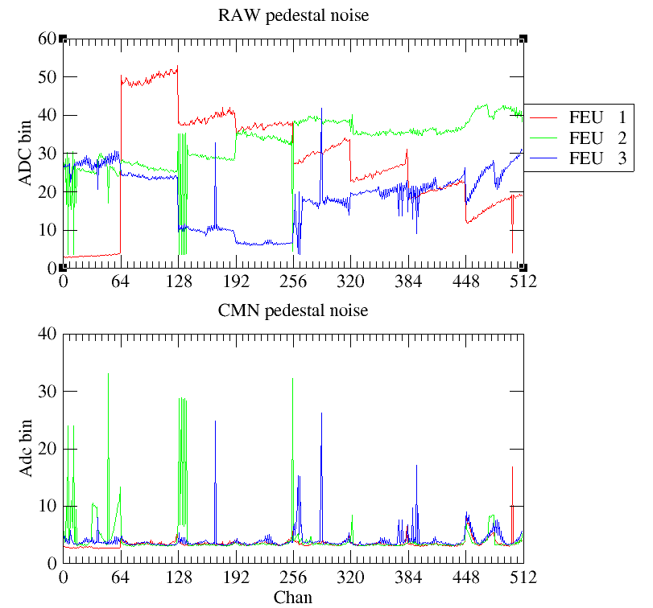
450 samples now standard.

Run 33: Quick HV scan with no box and aluminum plate on back of detector 3

Worked on triggering a bit with Riccardo. Have coincidence between scintillators set up.

Run 34: Quick run at operating voltage +635 and drift at -800V. Coincidence trigger also firing. Should be

Switched to B4C (2.5mm?)
On May 15 at 4:30PM we found that the B4C wasn’t aligned on the beam!

Run 35: Quick run which turned into a long overnight run at operating voltage +635 and drift at -800V. Coincidence trigger only firing, vetoing 2us after flash.
Thursday May 14

Found that Run 35 was weirdly stuck. When subrun_8 was starting DREAM sat at the initial screen and only started when I clicked “G” manually. Not the first time I have seen this. Maybe have claude take a look and possible do some unit tests (start and stop DREAM in batch mode to see if it fails)? If nothing else, try to have claude write a fall-back to manually G or restart if not running after some time – not ideal though, sacrifices simplicity of the code.

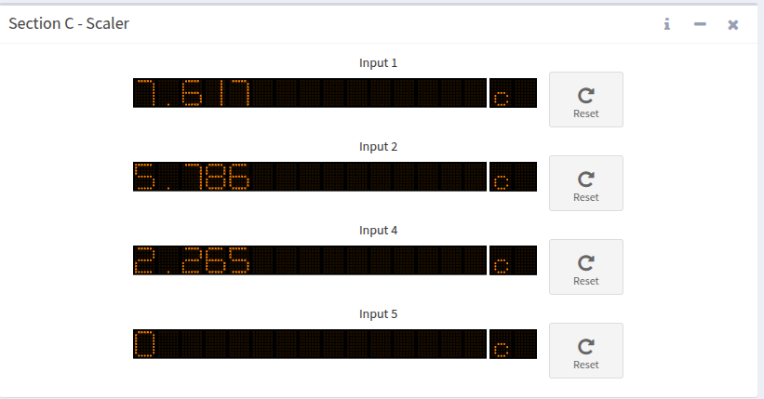

With carbon sample, we had 468 PS pulses and 1135 coincidence triggers. 1135 / 468 ~ 2.4

Run 36: Self trigger on det 3. Zero suppress and 100 samples.

Looks like copy on the fly isn’t working as intended?
Found that the disk has bottle-necks and locks up when transferring a lot of data. Before July, I should clone to the SSD and run off of that.

With B4C, we have 5786 PS triggers and 7617 coincidence triggers. There were 2265 coincidence triggers outside of ~2us from the flash. However, 7617 - 5786 = 1831, so somehow fewer total triggers actually fired. Means there must be some dead time on the trigger? Does this mean that the coincidence sometimes doesn’t fire during the gamma flash? Ah, yes we’ve seen this, I think maybe B1 sometimes does not fire? 7617 / 5786 ~ 1.31

With SiPM wall behind det 3 in coincidence with det 4 scintillator+PMT, get 353 coincidence, 272 PS tiggers. 353/ 272 ~ 1.3

With SiPM wall and scintillator behind it in AND – 874 coincidences with 201 PS triggers ~ 4.35
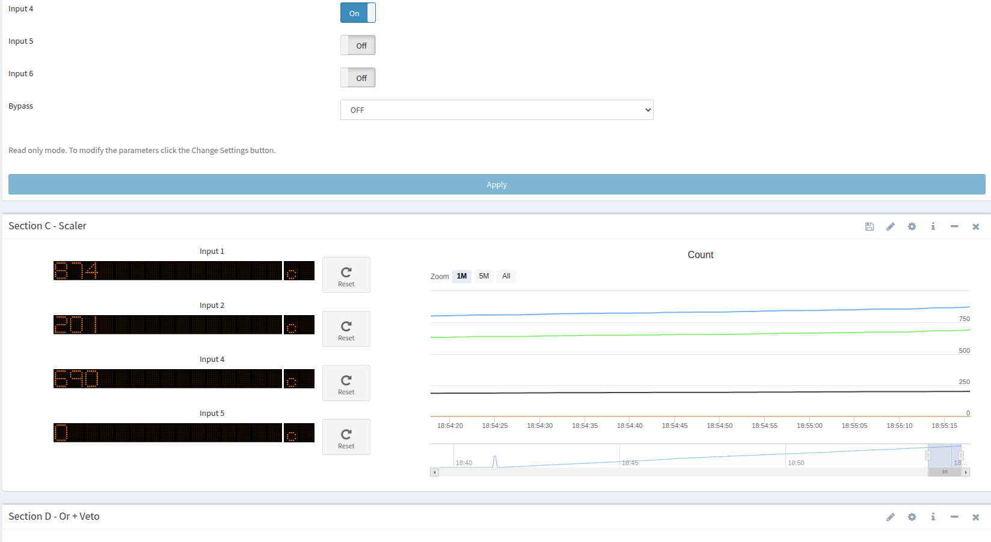
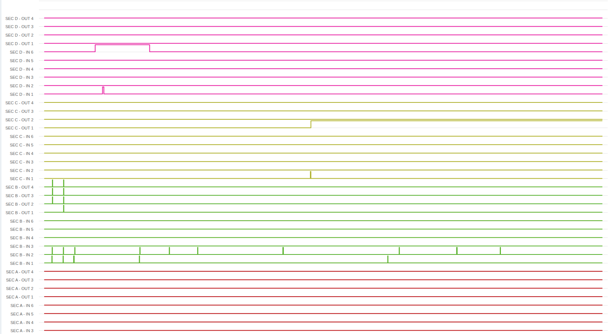

Run 37: Trigger on SiPM wall + scintillator behind it. Testing timing. Set to 300 samples and 150 delay.

Didn’t really see anything, going to 190 delay.
Run 38: Trigger on SiPM wall + scintillator behind it. Testing timing. Set to 300 samples and 190 delay.

Pushing HV to 650V

Run 39: Trigger on SiPM wall + scintillator behind it. Testing timing. Set to 300 samples and 190 delay. Resists at +650V. Think det 3 had problems at some point, couldn’t get to 650V for next run.

Looks like small hits every 1/10 events, would expect more. Play with timing to see if that could be the issue.

Run 40: Trigger on SiPM wall + scintillator behind it. Testing timing. Set to 300 samples and 2 delay. 650V on resists

Run 41: Trigger on SiPM wall + scintillator behind it. Testing timing. Set to 200 samples and 280 delay. 650V on resists

Ok pretty sure 190 delay is right. Go back to that

Run 42: Trigger on SiPM wall + scintillator behind it. Testing timing. Set to 300 samples and 190 delay. 650V on resists

Run 43: Set for HV scan. Trigger on SiPM wall + scintillator behind it. Set to 200 samples and 280 delay. 660V on resists, drop in steps of -5V for 20 minutes each.

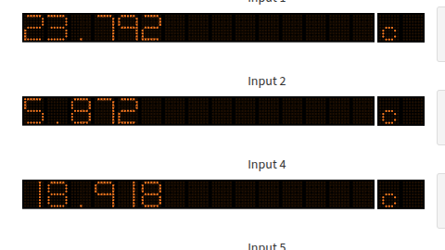

Run 44: Set for HV scan. Trigger on SiPM wall + scintillator behind it + other scintillator. Set to 200 samples and 280 delay. 660V on resists, drop in steps of -5V for 40 minutes each.
Friday May 15

Woof probably not a good use of the night, almost no coincident counts. 5772 PS triggers, 5605 (?) 3 way coincidence. 187 3 way coincidence that were not the gamma flash.
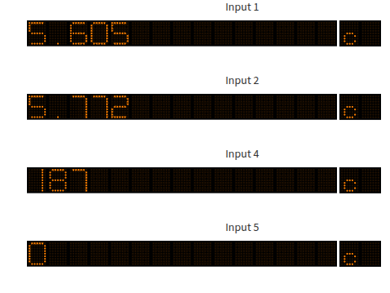

8:30AM Working toward ne/iso now. Made access while beam down to add labels.
9:30AM David came with team and connected the Neon/Isobutane. Did a leak test inside.
11:50AM They just came to put Isobutane labels on the line outside. Not on the tube.

Ar/CO2 Leak Test:
11:45PM Connected Ar/CO2 bottle to line 4. Opened to get ~60 bar of pressure and closed again.
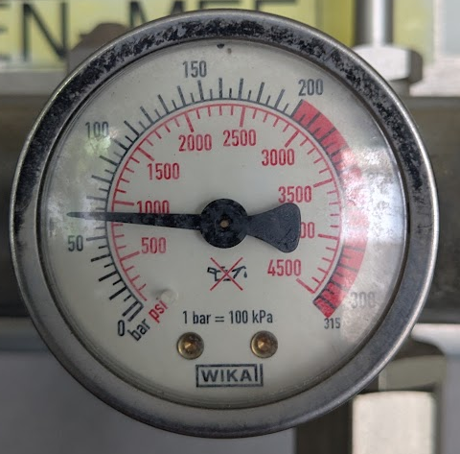
12:20PM No noticeable drop in pressure. Opened the line to EAR2, reopened the bottle to pressurize the line, and then closed the bottle.
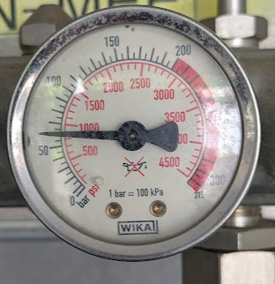

4:30PM Finally got clearance to flow Ne/Iso gas. Made access and turned on. Found that gas connector metal piece was on backwards – the tube went into the metal thread as shown in the picture below – must have been the cause of the substantial gas leak.
Also found that the B4C was not aligned on the beam, probably only a small percentage of the surface was in the beam. We think we must have been aligning on the reflected laser? Not sure if that checks out, but have to assume that all B4C data was unaligned.
Also switched the gas line connecting the detectors such that the exhaust of detector 3 on the bottom goes to the the top of detector 4, hopefully allowing neon to more effectively push the argon down and out.
Also removed aluminum from back of MM detector 3 before SiPM wall.

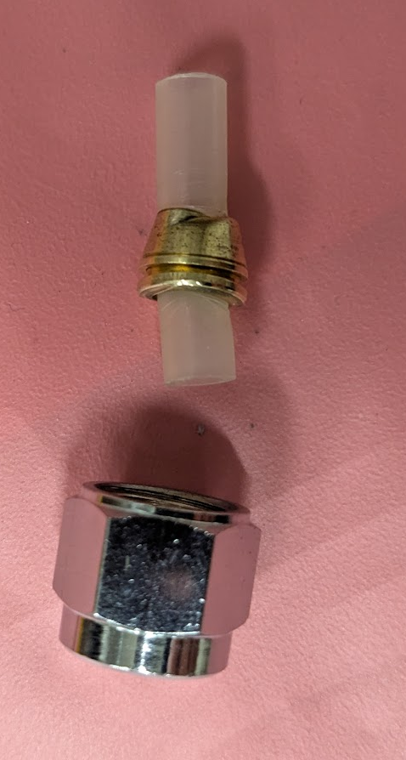

4:30PM Flushing Neon/Isobutane 95/5 at ~10L/hr.

In the mean time, running scintillator coincidence tests with the aligned B4C.

Section B Inputs:
Input 1: Scintillator A (On detector 4)
Input 2: Scintillatot B (On detector 3)
Input 4: Sum of Scintillator Wall (On detector 3)

Realized that some settings were weird, counts of coincidence from before may have missed some. Now send monostable outputs from the coincidence section B. Before, I think if the overlap was too small the coincidence scalar wouldn’t fire.

Detector 4 scintillator + Detector 3 Wall:
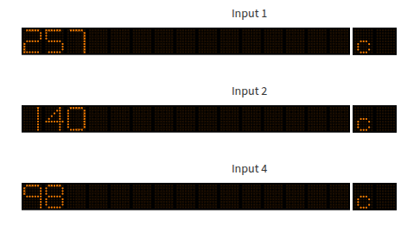
Total Coincidence: 257
Total Pulses: 140
Non-2us triggers: 98
Non-2us trigger per pulse: 98 / 140 = 0.7

Detector 3 scintillator + Detector 3 Wall:
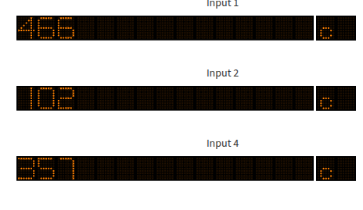
Total Coincidence: 466
Total Pulses: 102
Non-2us triggers: 357
Non-2us trigger per pulse: 357 / 102 = 3.5

Detector 4 scintillator + Detector 3 scintillator + Detector 3 Wall:

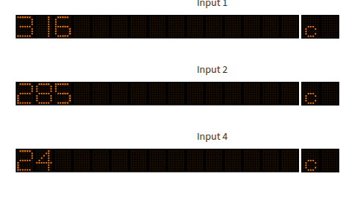
Total Coincidence: 316
Total Pulses: 285
Non-2us triggers: 24
Non-2us trigger per pulse: 24 / 285 = 0.084

5:45PM Made access with EAR1 to change from B4C to empty carbon capsule. Detectors seem to be bubbling ok.
6:00PM Neon/Isobutane pressure still at around 20 bar after 1.5 hour at 10L/h.

Detector 4 scintillator + Detector 3 Wall:
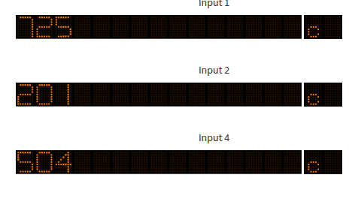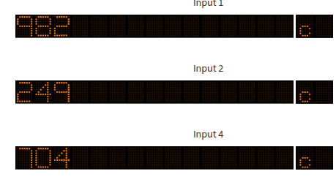
Total Coincidence: 1707
Total Pulses: 450
Non-2us triggers: 1208
Non-2us trigger per pulse: (504 + 704) / (201 + 249) = 2.68

Detector 3 scintillator + Detector 3 Wall:

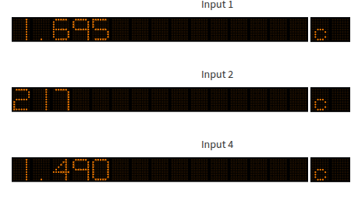
Total Coincidence: 1695
Total Pulses: 217
Non-2us triggers: 1490
Non-2us trigger per pulse: 1490 / 217 = 6.87

Detector 4 scintillator + Detector 3 scintillator + Detector 3 Wall:

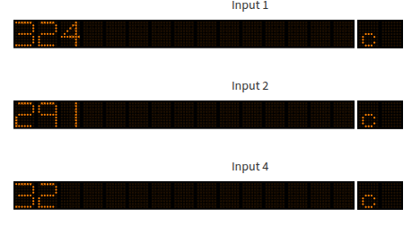

Total Coincidence: 324
Total Pulses: 291
Non-2us triggers: 32
Non-2us trigger per pulse: 32/291 = 0.11

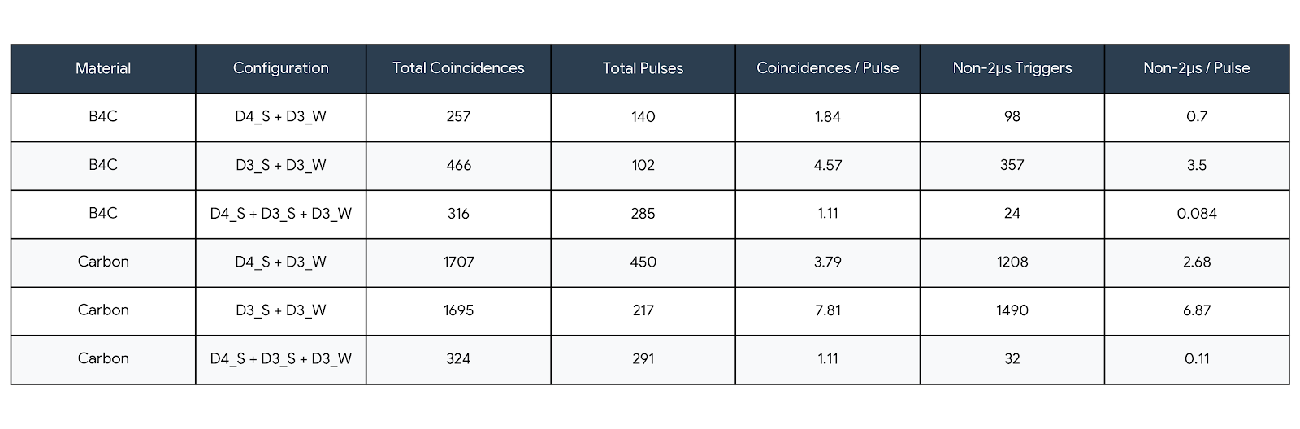
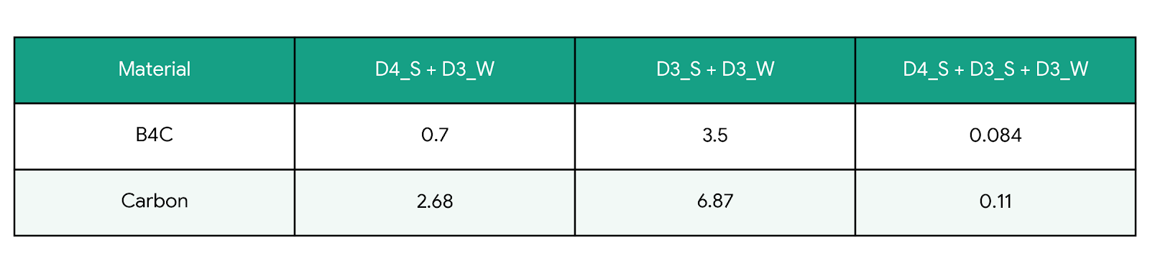
D4_S + D3_W: Detector 4 Scintillator + Detector 3 Wall
D3_S + D3_W: Detector 3 Scintillator + Detector 3 Wall
D4_S + D3_S + D3_W: Detector 4 Scintillator + Detector 3 Scintillator + Detector 3 Wall
Material: Target
HAD ALL INDIVIDUAL CHANNELS IN NON-MONOSTABLE! COINCIDENCE LARGE!

Run 45: First gas change run with Neon/Isobutane. Starting about 2.5 hours after changing gas and running at ~10L/hr. Had sparks on detector 4 drift when ramping to -800V, so set both to -600V where they seem stable. Set Resists to +500V for now – started to see current fluctuations around 470V. Carbon target.
gas_change_0: Trigger on 3-way coincidence between det 3 scint, det 4 scint, and det 3 wall sum.
Gas_change_1, 2: Changed trigger to det 3 scintillator and det 3 scintillator wall coincidence.
Gas_change_3-7: Removed veto on gamma flash, should see that plus the other triggers (unless dead time).

Run 46: Another gas change run with Neon/Isobutane. Start with Resists at +500V and drifts at -600V. Carbon target. Trigger on det 3 scintillator and det 3 scintillator wall coincidence and removed veto on gamma flash, should see that plus the other triggers (unless dead time).
gas_change_0: +500V on resists.
gas_change_1: +490V on resists.
gas_change_2: +480V on resists.
gas_change_3: +470V on resists.
gas_change_4: +460V on resists.
gas_change_5: +450V on resists.
gas_change_6: +440V on resists.
gas_change_7: +430V on resists.
gas_change_8: +420V on resists.
gas_change_9: +410V on resists.
gas_change_10: +400V on resists.
8:45PM Made access and turned flow down to just over 2L/hr, will need to lower a bit more tomorrow. Also plugged in DREAM 1 of Det 3 X, which has up until now been in the GBOX. Riccardo connected 4 SiPM lemos in the area rather than outside.

Run 46: Another gas change run with Neon/Isobutane. Start with Resists at +500V and drifts at -600V. Carbon target. Trigger on det 3 scintillator and det 3 scintillator wall coincidence and removed veto on gamma flash, should see that plus the other triggers (unless dead time).

Run 46: Another gas change run with Neon/Isobutane. Start with Resists at +500V and drifts at -600V. Carbon target. Trigger on det 3 scintillator and det 3 scintillator wall coincidence and removed veto on gamma flash, should see that plus the other triggers (unless dead time).

Run 47: Large Drift and HV scan with Ne/Iso. Only 1 minute runs, but drift of 0, 100, 300, 600. Resists from 550 in steps of -10V to 360V.

Run 48: Garbage

Run 49: Intended to be a long overnight scan, but hung at RunCtrl “G”.
Saturday May 16

Run 50: Garbage

Run 51: Started quick HV scan in Ne/Iso in steps of -10V from +550V on resist, -600V on drift. 5 minute runs.

Neon looks like better tracks in the low energy than Ar/CF4
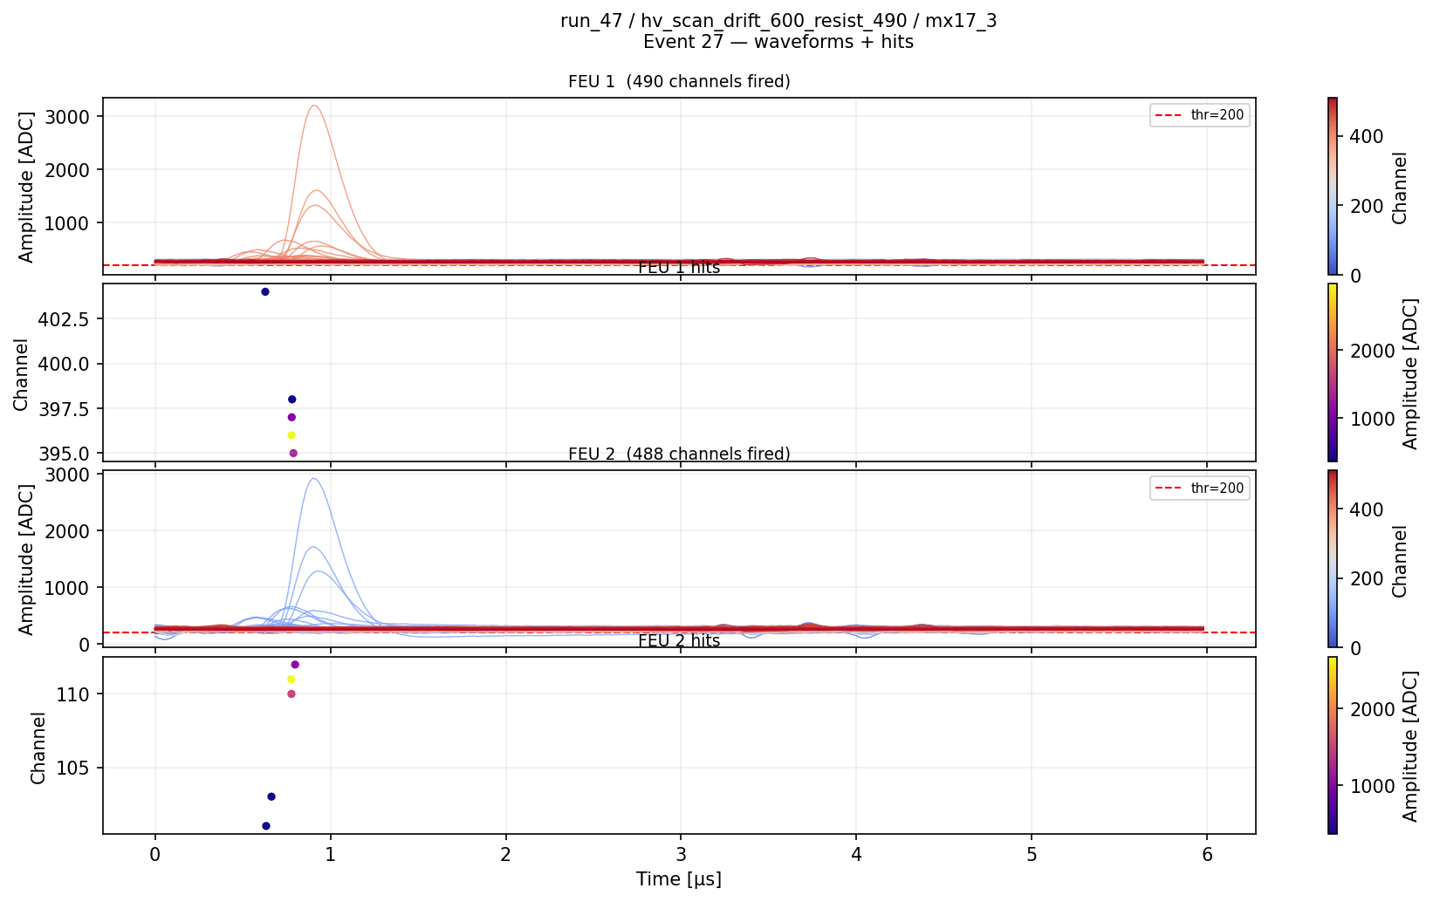
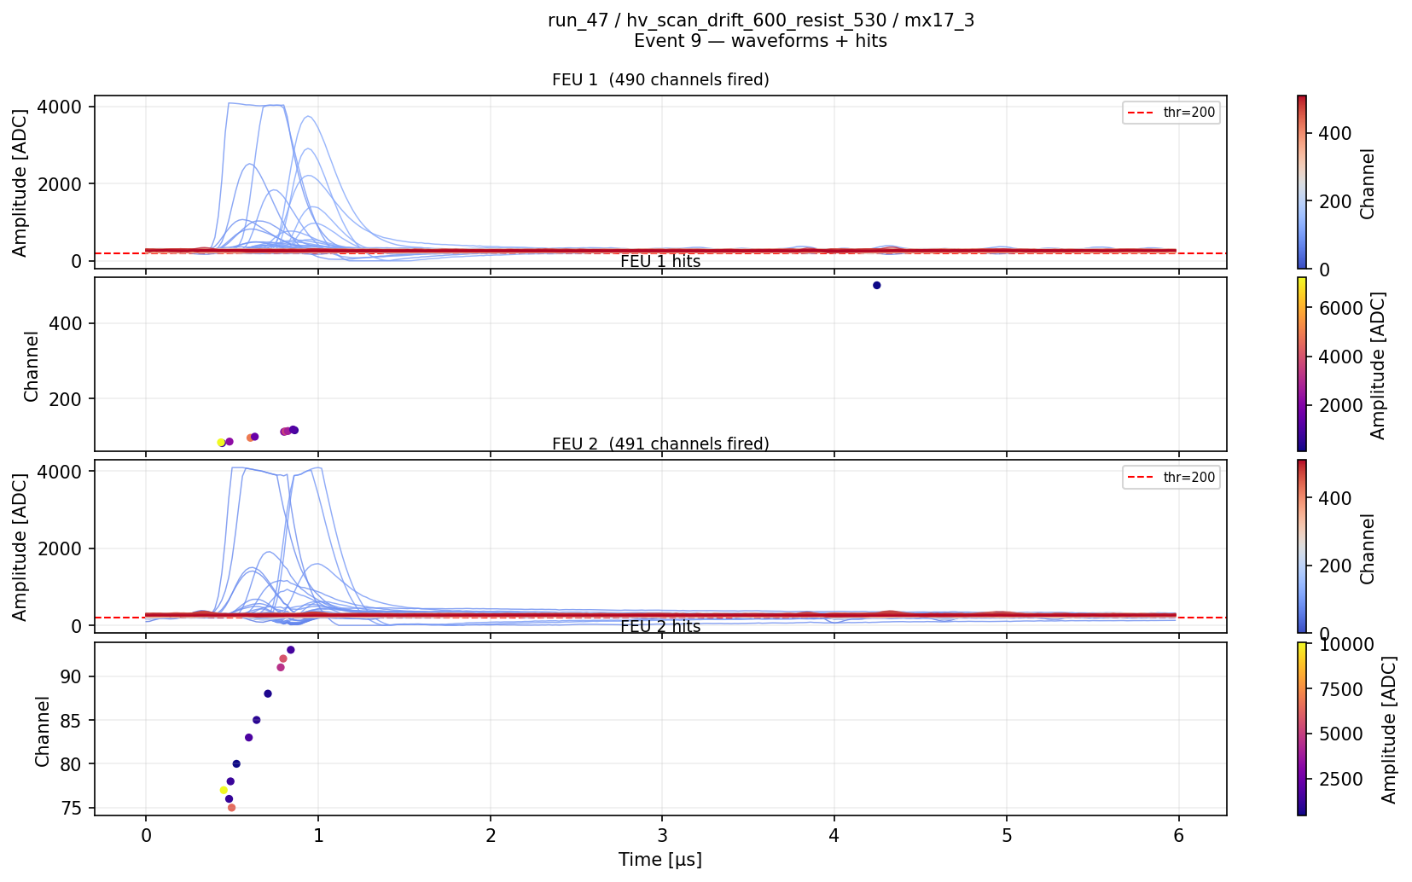

Run 52: Ideally longer run at +530V. TCM somehow died at the end.

Run 53: Garbage

3:30PM Lost TCM communication somehow during Run 52. Couldn’t ping it at all Made access and found it had a red light. Power cycled and seemed to work.

Run 54: Started quick HV scan in Ne/Iso in steps of -10V from +550V on resist, -600V on drift. 2 minute runs. Trigger on det 3 SiPM sum + det 3 scintillator coincidence. Was trying to test the GBox but the ramp was not plugged in → not useful.

5:40PM: Entered and switched from Neon/Isobutane to Helium/Ethane. Neon/Iso pressure looked low, unclear how low, but less than 10. Realized that I was using the flow meter calibrated for Argon/Isobutane 90/10. AI says we would have 1.5 times as much flow with neon. If we’re then at about 6-7 bar it could make sense.

Left the Helium/Ethane flushing at a reading of 8L/h, which from the table below is more like 24L/h.

Need to ask Letizia about wifi switch for rack and possibility of a gas mixer, either in the area or outside.

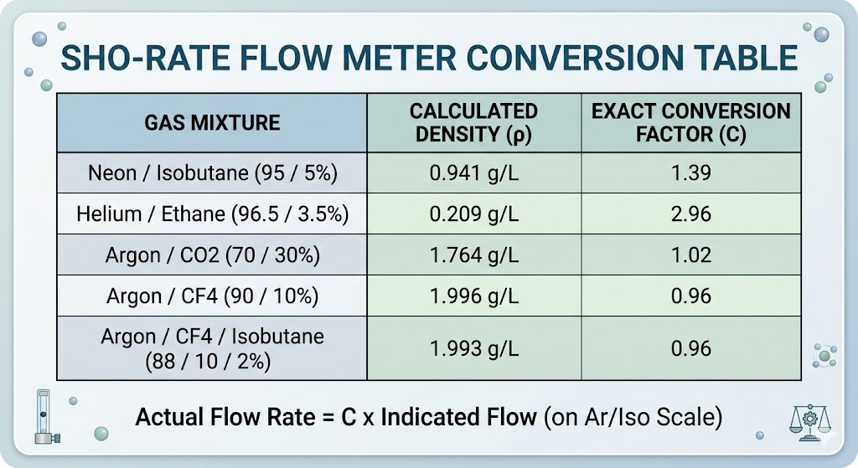

Sr90 Beta spectrum
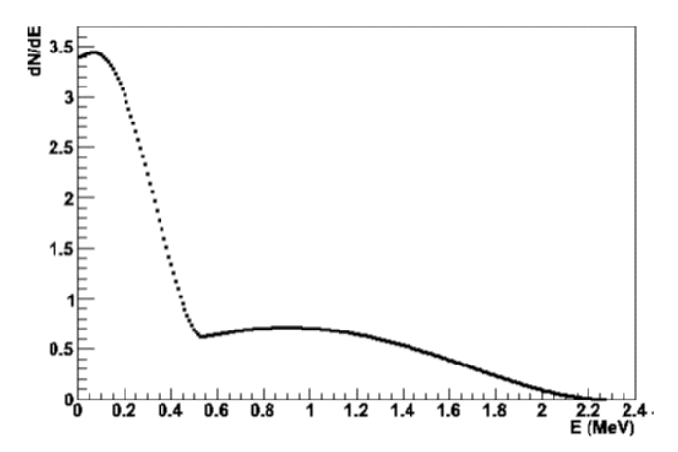
Run 55: Gas change run in transition from Neon/Isobutane to Helium. Sit with the usual Wall 3 + Scint 3 trigger with drifts at -600V and resists at +550V.

Weird RunCtrl errors on this run?
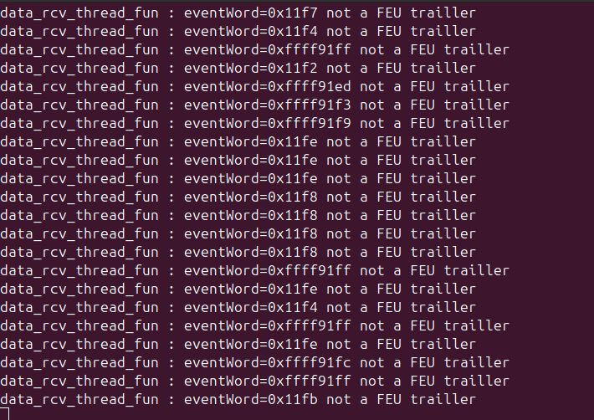

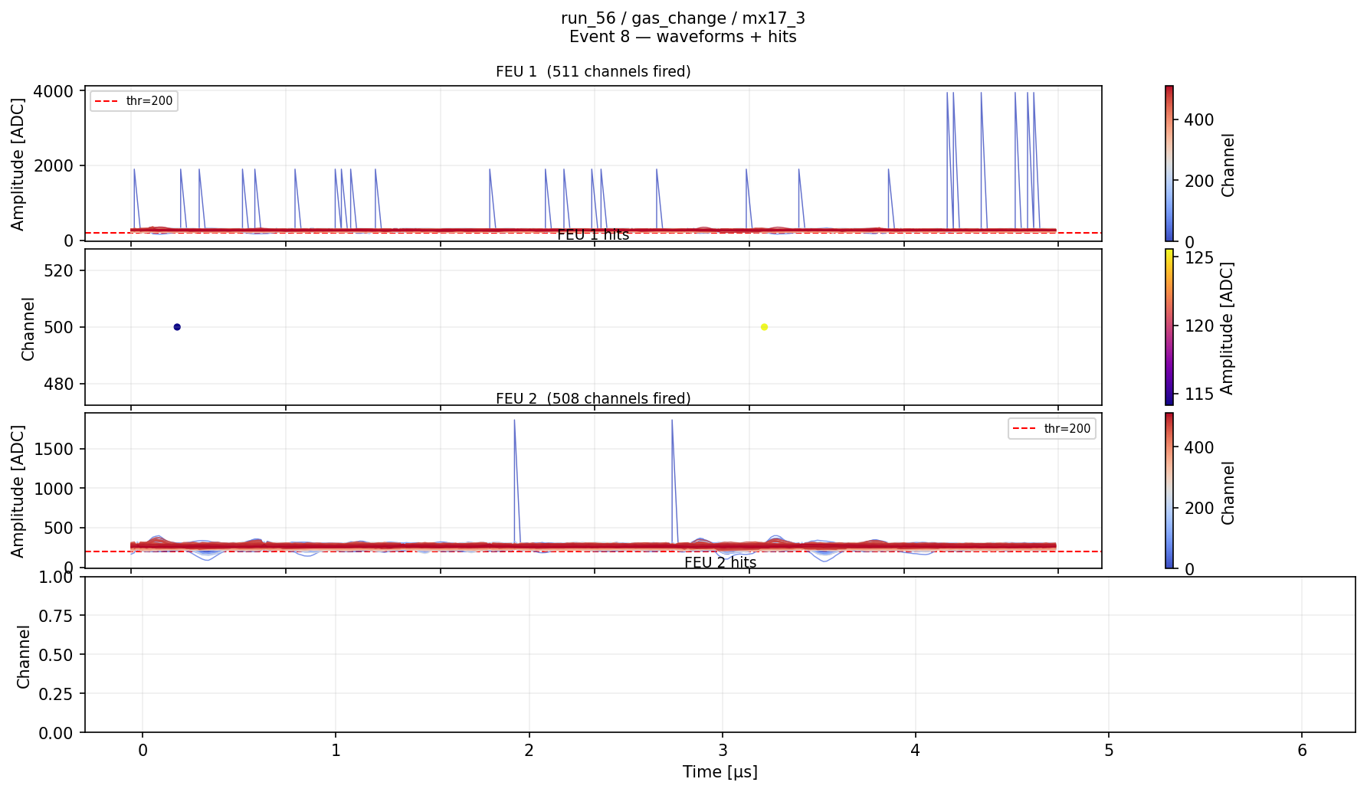
Definitely data corruption.

7:40PM Access to turn flow rate down to ~2L/hr which is ~6L/hr for Helium.

Run 56: Ran a no_beam run while making gas flow change. The usual Wall 3 + Scint 3 trigger with drifts at -600V and resists at +550V. Carbon target.

Ran a pedestal before beam came back.

Run 57: Short run before restarting

Removed the watchdog on the dream_daq_control.py.

Run 58: Hopefully long gas change run after removing watchdog. The usual Wall 3 + Scint 3 trigger with drifts at -600V and resists at +550V. Carbon target.

ToDo:
- Get event counter on DAQ working
- Add a watcher to check for problems and whatsapp me if so
- On daq_status explicitly look for the data_rcv_thread_fun error

Dream RunCtrl kept getting killed. Finally realized it was the QA blowing memory. Tried to have claude run the qa in such a way that it would die if it used too much memory, to be tested.
Also started adding a telegram alert system but no triggers yet.
Possible that we send too many triggers to Dream, but I don’t think so. Maybe reject with dream busy anyway.

Run 59: Gas change runs, don’t remember what was happening here.

Run 60: Overnight scan. The usual Wall 3 + Scint 3 trigger. Start with 30 minute Resist and Drift scans while waiting to flush. Finish with a ~4 hr run with -600V drift and +515V resist, should be start of the plateau from CEA calibration. Carbon target. The final run only went for 30 minutes instead of the intended 4 hours from my run config mistake.

Sunday May 17

Run 61: Single stats point with He/Eth. The usual Wall 3 + Scint 3 trigger. -600V on drifts +515V on resists. Carbon target.

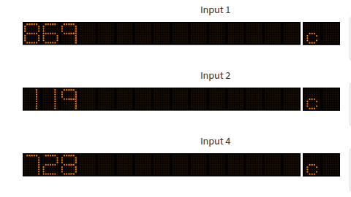

11:45AM Made access to switch gas from He/Eth to Ar/CF4/Iso. Rewired the gas tubes such that the argon is coming in from the bottom of each detector and out the top – push helium up and out.
Found that the filters were in this configuration the whole time. Since the valves were outside of the filters (further from the detector), the filters must have been like this the whole time. So at least something wrong in each configuration.
Set Argon/CF4/Isobutane at a flow rate of ~20L/h (can only measure up to 8L/hr, so did 8 turns after).

Riccardo realized today that he took one channel out of the SiPM sum in the NIM module for the trigger to test

Run 62: No beam. The usual Wall 3 + Scint 3 trigger. Start with 30 minute Resist and Drift scans while waiting to flush. Finish with a ~4 hr run with -600V drift and +515V resist, should be start of the plateau from CEA calibration. Carbon target.

Took Pedestal.

Run 63: Very sketchy gas change run with Helium/Ethane going to Argon/CF4/Iso. The usual Wall 3 + Scint 3 trigger. Drifts at -600V, resists starting at +520V and dropping in steps of -10V with 5 min runs. Carbon target. Gas is changing, not a gas-stable run!

Input 1 is coincidence of det 3 scint and det 3 wall. Input 4 is the same after or veto, though veto is off so they really should be the same. Input 2 is PS triggers. Carbon target each of the 16 channels separately in the rack room.
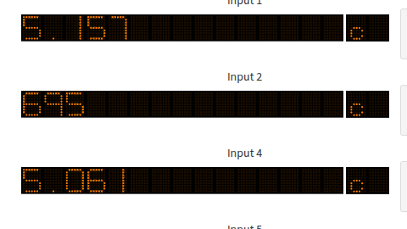

1:15PM Access to combine siPM wall channels into groups of 4 in the area with Ts, rather than sending all 12 out individually and combining in the NIM module with Ors. Previously, we had 6 on top 6 on bottom, staggered. Now we have 12 on top. Will have to see if that makes any difference?

Tested the Line 5 flow rate meter outside. After opening the flow rate limiter in the area all the way and then adjusting the one outside, was able to get matching at 3L/h. When I went to 7L/hr outside, it showed higher inside, above 8L/hr, so not totally sure. Probably delay in the line pressure, maybe outside it’s also higher now too?

Run 64: No_beam gas change run with Helium/Ethane going to Argon/CF4/Iso. Riccardo working on trigger so not so reliable. The usual Wall 3 + Scint 3 trigger. Drifts at -600V, resists at +515V. Carbon target.

Took Pedestals.

~1:55PM Changed flow rate outside to 14L/hr

ToDo:
- Finish testing the triggering with combining the scintillator wall
- Fine tune the analysis for turn on/turn off curves. Run on Helium and any neon we might actually have.
- Try to compare tracks between Helium and Neon (and maybe Ar/CF4).
- Look through CERN available gases.
- Simulate electrons through our full setup.
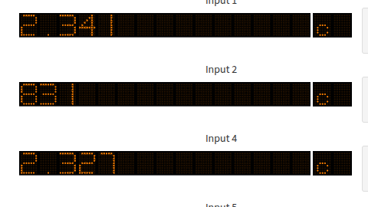
Ratio of coincidence to PS: 2341 / 831 = 2.82

With top bottom alternating instead of all top at -10mV threshold.
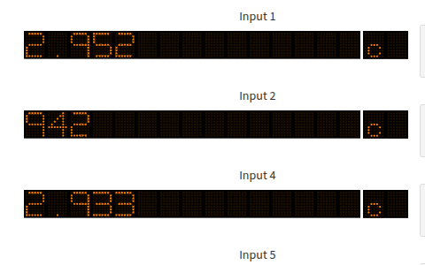
Same but -5mV threshold
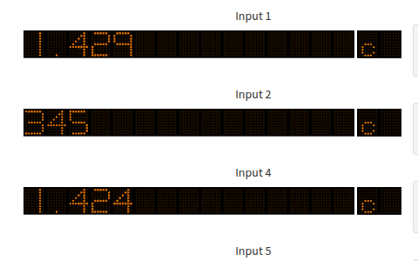

Going in with the sr-90 source. Try to shoot in from the back at an angle while hitting scintillator and sipm wall. Take some data with ntof to get an idea of MIP signals.

~7:00PM Changed Argon/CF4/Iso bottle to the new one.
Old one at 20 bar, new one around 120bar.

Realized that N1081B needs at least 10mV signals! Values below don’t work!
Combined Sipm wall trigger at +4mV
Individual Sipm wall trigger at +10mV
Eraldo at -7mV @ 1300V

Was getting monostable output 50 ns wide from 6 channel or in left NIM module.
Realized that we didn’t have monostable inputs on the 6 channels, so more coincidences than in reality.
Setting inputs of the ORs to 25ns, threshold +4mV. Setting OR output to 50ns monostable.

Concluded that N1081B needs signal of at least 10mV for threshold on channels. Also attenuate leaving the area of possibly factor or 2 or 3.
Conclusion – Need to bring all triggering logic into the area.
Conclusion – Need to increase signal size from scintillators as much as possible.
Tomorrow – Calibrate to MIPs in rack room.

For cat cable more like 16 ns or so would be ideal. Keep pulses at amplitude.

Run 65: Probably sr-90 test?

Run 66: Maybe more sr-90 test?

Run 67: Just while we were figuring out trigger stuff. Drifts at -600V, resists at +515V. Carbon target.

Run 68: Test to see tracks after gas flush with new bottle. Drifts at -600V, resists at +535V. Carbon target.

Changed hv_control.py to allow monitoring only for HV channels by setting to None in config.

Run 69: Run while pushing HV up.. Drifts at -600V, resists start at +540V. Carbon target.

Run 70: Set to overnight run with Ar/CF4/Iso. Trigger Det 3 Wall + Det 3 scint, vetoing on PS. After a lot of sparking got the detectors to +800 resist, drifts at -600V. Sit here for a couple hours, then quick 30 min -10V step HV scan till ~+740V. Then back up to +790V till dismount. Carbon target.

Monday May 18

Run 71: Set to run with Ar/CF4/Iso. Trigger Det 3 Wall + Det 3 scint, not vetoing on PS. +790 resist, drifts at -600V. Till dismount. Carbon target.

Run 72: Running in corner in cosmic mode. Set for ramp up. Ramped to +790V on resist. Swapped resist and drift cables with det 4.

Run 73: Running in corner in cosmic mode. HV scan from +800V in 10 minute runs steps of -10V.

Run 74: Running in corner with sr-90. Hopefully see some tracks, but not a very productive test this fast.

Tuesday May 19

Packed everything and brought all but rack to Jean-Yves to bring back to Saclay. Looked into the bent scintillator PMT BNC and emailed Eraldo, said it’s ok they will try to fix at GDD.

Wednesday May 20

Brought DREAM rack to CEA antenne.
Turned off both gases at the bottle but left the line to EAR2 open to measure leak.

Gas Accounting:

In the end think we used 2 bottles of Ar/CF4 90/10:
- Started at 65 bar, 50L. Started with cosmics on Friday to Saturday, connected in area on Monday. Empty on Wednesday Morning
- Started at 70 bar, 50L. Started on Wednesday morning and I think we were out by Friday morning when we wanted to plug the neon.

Used Ne/Iso 95/5 from Friday night to Saturday night – why did it go so fast? We were underestimating flow rate by factor of 1.5 but still think it should have lasted a bit longer?

Used Helium/Ethane 96.5/3.5 on Saturday night after the neon till sunday. Started at 140 bar and ended only a few bar less, maybe 148.

Used Ar/CF4/Iso 88/10/2 after the neon on Sunday after Helium. Started with a mostly empty bottle just under 20 bar, ended not much lower a couple hours later. Switched to a new bottle Sunday evening starting at ~113 bar, and ended around 110 bar.

Total bars of 10% CF4 in 50L bottles: 65 bar + 70 bar + 3 bar = 140 bar
AI said 1kg / 60 bar so about 2.4 kg of CF4 :|

I realized on May 21 that DREAM Zero Suppressed mode had been on for the entire second half of the test, after I ran the explicit ZS run! This explains why the gamma flash looked so odd fo neon and afterward, the common noise subtraction was pulling all the channels down when they saturated. Not entirely sure the repercussions here – need to be careful when analyzing. Will need to reprocess all runs and think about how to do that. I think we explicitly tell the processor we’re in ZS mode? Should I implement something to read the DREAM config file and decide on the processing with/without ZS (basically just pedestal question) based on the config?

Test Summary

We brought two detectors to test, both with resistive strips. We only had 4 M1 cards, so could only fully read out one of the two detectors. For the other, we used the 2 to 1 multiplexed M2 cards. We haven’t done any algorithmic work with multiplexing so we will not get any reconstruction from the M2 detector. When we arrived we knew detector 3 was mostly efficient in Argon/Isobutane 95/5 from the cosmic bench, and had efficiency plateau curves for it with Helium/Ethane 96.5/3.5 and Argon/CF4 90/10. There were issues with detector 3 efficiency in the cosmic bench I wasn’t able to quite figure out, it looked like maybe discharges were induced by cosmics, moving the reconstructed center of the event toward one side of the detector. Detector 4 was newly constructed and had only been in the bench for one night before we left, and I didn’t have time to do an analysis until Saturday, when I realized it was not efficient (only a small patch seemed to pick up reasonable correlation). We therefore made the decision to focus on detector 3 as the main test detector and try to use detector 4 to cross-check/validate with M2 cards. Detector 3 had a floating mesh which was needed to test the mesh injection circuit, while detector 4’s mesh was not floating so couldn’t be used for this test. We had one adjustable drift window, which we could take from 3.6mm to 16mm.

When we arrived on Friday we tried to get the detectors in gas and take cosmics to validate the efficiency curves we found at CEA for Ar/CF4 90/10 and get a measurement for Ar/CO2 70/30, which we hadn’t been able to run at Saclay. We had borrowed two 30x30cm scintillators+PMTs from Erlado at the Gaseous Detectors Development (GDD) lab. We stacked these and triggered on coincidence, which should be mostly cosmics. We ended up with a rate of about 5.5Hz, which is reasonable for the detectors only a couple of centimeters away from each other. We seemed to have some success with cosmics with efficiency curves that looked reasonable, but the data wasn’t as clean as expected.

We found that detector 3 was drawing a lot of current, not something that we saw at Saclay. It seemed to be spark-like behavior, but something that we could mostly deal with. We just had to push very slowly to whatever voltage we wanted and wait until it finished sparking. On Sunday we decided to focus on detector 3, so moved the adjustable mesh to this detector in GDD. We found that the drift on detector 4 could only go to around -900V in air, and found discharges even less with gas during the beam. We tried to fix it and seemed to improve things by taping with kapton on the HV box corner, but still wasn’t perfect and we kept the drift field relatively low for the whole test.

When setting up on Monday, there was a problem with the gas line and we had developed a sizable leak. We checked that this was not a leak on our detectors, but did not check the line itself. It was due to a connector put on backwards (from the plastic tube to the metal tube). We mounted the detectors at a 90 degree angle. There was difficulty adding the second detector after realizing that the 5mm of rochelle added meant that the second detector couldn’t be inserted fully. The SiPM wall was placed behind detector 3 and one of the GDD scintillators was placed behind that, with the PMT pointing up. The other GDD scintillator was placed behind det 4. We realized later that they were pretty low on the detector active area, with the tips of the scintillators extending a couple of centimeters below the frame of the detector, so the top of the scintillators would have been just above halfway in the micromegas.

We flushed on Monday with Ar/CF4 90/10. We then took some data to verify that we were still saturated during the gamma flash as we saw in February. We triggered directly on the PS pickup. We then noticed a strange behavior of the waveforms from DREAM, with some channels getting stuck at 4096. We later discovered that this could be fixed by reducing the number of samples per event, but this was a large distraction and was solved with the help of Simone and Julio and Irakli when we got the noise generator working, I think on Tuesday.
We tried putting the 2mm thick aluminum plate on detector 4 to see if that helped with the gamma flash, but even on a very short test we found no difference so discarded the idea – our flash must be coming from high energy particles rather than x-rays photo-electric effecting in the Argon.

We spent some time trying to make the mesh injection circuit work. We actually may have had some slight success with this, as we saw that when it was on we seemed to see more tracks at the same saturated voltage after the flash than when it was off. This should be looked at a bit more carefully, though the 4096 issue makes the analysis a bit more nuanced. We found that the injection circuit was probably killed by the HV of the detector – it is connected to the floating mesh but when discharges happen (very often for detector 3), the ~400-800V of the resistive layer can jump to the mesh. We think this killed the circuit and we weren’t able to play with it to test. It’s possible that this route may actually be feasible to solve our gamma flash problem and make a reading at high energy, but we don’t have another testing opportunity to iterate on this idea. My understanding of this circuit is that it injects positive charge on DREAM which helps somehow cancel the negative charge buildup from the flash, though I suspect this understanding may be naive.

We had considerably worse noise this test than we did in February. Due to the 4096 issue we did not have much time to systematically focus on this noise and try to reduce it, though the grounding we attempted didn’t seem to help. I don’t know what we can do for July but it will be important to try what we can – mostly an aluminum foil on the back of the detector, behind the rochelle.

On Wednesday night after finding that neither the aluminum plate nor the mesh circuit seemed to be enough to allow us to make the measurement at high energy, we decided to focus on the thermal measurement. In practice, this is almost an entirely new experiment. The first job here is to figure out how to trigger on thermals. We were lucky to have the scintillator wall and the GDD scintillators, so could do some testing. We knew from February that triggering on a single wall or single scintillator would be much too noisy and DREAM’s dead time was much too large to sample that kind of event rate. With two scintillators in a row, we should be able to reject single energy depositions (photons) and skew toward triggering on charged particles (our signal e+ and e-). There was an aluminum plate on the back of the SiPM wall before the GDD scintillator, so I worry this stopped many of the ~MeV level charged particles. This was somewhat confirmed with the Sr-90 test, where from the GDD scintillator side we saw very little on the SiPM wall, but saw quite a bit from the other side. Requiring the coincidence of the SiPM wall and the det 3 GDD scintillator behind it reduced the trigger rate considerably, down to around 7 triggers per pulse with the empty carbon capsule. However, we know that the coincidence rate will increase for July for 3 reasons:
- The aluminum plate on the SiPM wall will be removed or replaced with foil.
- The GDD scintillator was only 30x30 cm instead of covering the full MM 40x40 or SiPM wall 50x50.
- The carbon capsule will be full of He3 in July, which will produce much more signal and background.
The question then is whether we can survive the singles rate when triggering on these types of coincidence (“singles” being coincidence between scintillators in a row). For DREAM, we can lower the number of samples taken to reduce dead time. We can also consider going to zero suppressed mode, though the noise will probably hurt us in this reduction.

The plan for July is to have the 4 SiPM walls as planned. We will also have behind those a series of liquid scintillators. The plan is for 4 layers of liquid scintillator per wall, 1 cm each. The idea is to get both a trigger and calorimetery. We would use a coincidence between the SiPM wall and the first layer of the liquid scintillator to trigger a “single”. The goal then, is to make sure that our lowest energy signal electrons/positrons, around 1-2 MeV, make it all the way to the first liquid scintillation layer and deposit enough energy there. That needs to be simulated. After that, the electron/positron will enter the rest of the liquid scintillator and hopefully deposit the rest of its energy there, allowing us to reconstruct the energy of the particle track seen in the Micromegas and looking for a resonance at 17MeV. The challenge on the other side is to make sure the liquid scintillator is thick enough that the max energy electron/positron, around 10 MeV, will be fully stopped in the liquid scintillator and therefore allow us to measure its full energy. The stopping distance for the JUNO liquid scintillator seems to be about 5 cm.

An additional complication found from conversation with AI is that a positron will annihilate at the end of its path, converting its rest mass to two 511keV photons. These photons have a radiation length of around 10cm, so we’ll definitely lose those. Have to think about the implications, hopefully just a definite 1MeV uncertainty on the energy.

To make the trigger work, we will need to combine all of the SiPM channels in each wall into a single logic output. We tested this on Thursday through Sunday. First, we piped 12 channels of the wall out to the rack room and plugged into the CAEN NIM module. We mistakenly fired on any logical or when any two of the channels were above threshold. This was too wide, we should have triggered only on the leading edges, accomplished with a monostable output from the channels’ discriminators.

For July, we can only depend on having ~52 channels in the n_tof DAQ. That means about 13 channels per wall. I believe that the plan is to read out each layer independently for energy deposition vs distance – 4 channels for the liquid scintillator. We are then left with 11 channels per SiPM wall. There are 20 bars per wall and each bar has 2 SiPMs on top and 2 on bottom. We decided to group and read only 10 channels total. Since the liquid scintillator will only be 40x40cm like the MMs and since the MMs won’t be so efficient on the edges, we decided not to read the left and right 2 bars (2.5cm bars, 2.5cm *4 = 10cm, 50cm - 10 cm = 40cm). So there are 16 bars left to read. The goal is then to read out 4 channels on top and 4 on bottom symmetrically. We’ll then need to sum 4 bars together – unclear if only 1 SiPM per side (top/bottom) per bar or two. In the end, we’ll have 8 readout channels per SiPM wall. That makes 12 channels per side, then 48 channels total, within our 52 budget.

The liquid scintillator should hopefully be straightforward – each layer gets its own HV and readout. For the first layer, we will need to somehow split the signal to use in our triggering logic.

For the SiPM wall, it will take a bit more work. I believe that we decided to read out 16 of the 20 bars on each wall, leaving two on each side off to match the profile of the liquid scintillator. We will then combine 1 or 2 SiPMs from each of 4 bars on each side. So that’s either 4 or 8 → 1. We envision this being done very soon after the SiPM in the readout chain, either directly from the blue cables or on the board before the lemo connectors. Otherwise, we will have to use linear fan-in-fan-out modules (LeCroy 428F) which have 4 independent sections of 4 in 4 out (invertible for either polarity output and zero adjust). In that case, we would need 2 modules per wall, reading 1 SiPM per bar – 8 total. That will give us 4 combined channels on top and 4 combined channels on bottom, covering a width of 10 cm each (2.5 * 4). Ideally, the signal will be fast enough that comparing arrival time on top and bottom we can provide some kind of vertical constraint on the particle, maybe to 5cm or so? That gives us a spatial resolution in the SiPM wall of about 10cm wide by 5 cm vertical – not great but a good cross-check of the MMs. These 8 output lemos per wall will then need to be split – part going directly to n_Tof daq for readout and part going to trigger logic. It sounds like this split would be better to do with another linear fan-in-fan-out to maintain signal amplitude and reduce reflections. For the trigger logic, we will then need to combine the 8 channels for each wall and discriminate into one logic trigger per wall. For this, we can use a linear fan in - fan out (LeCroy 428F), which should sum analog input voltages in groups of 4. For modules with 4 groups of 4 input, we would need at least 3 modules: 2 sections per module to sum walls in groups of 4 – then two walls per module. For each wall this would then output 2 summed signals, which would have to go to another module where these two are summed – one section for each wall. In the end, we have 1 summed analog signal for each wall. This would match the one analog output from the liquid scintillator layer 1 behind each wall. From here, we will need to discriminate and trigger on the coincidence between the paris of sipm wall sums and the liquid scintillator layer 1s behind them. This can be done in one full CAEN NIM N1081B module using one section per sector, using a monostable output of 20-50 ns to ensure we are triggering on the leading edge, not the full pulse over threshold. Then, the output of each of these sections would be the good charged particle coincidence trigger for each sector. These 4 logic trigger output would then go to another N1081B module. Since we can have up to 4 output copies of these triggers, we’ll use two for each. The first set of 4 will go to section A of the next N1081B module – the “Singles” trigger. This will simply fire on an OR of any of the 4 input logic triggers. The second set of 4 output triggers will go to section B of the second N1081B – the “Dobules” trigger. This will fire on the majority (2 or more). We end up with a Singles and Doubles output trigger. We always want to fire on the Doubles trigger. Ideally we fire on the Singles trigger and forget the doubles, but if our singles rate is too high we’ll have to try to scaledown the Singles somehow. Section C can be used as a veto combination OR, at least taking the DREAM busy and maybe the PS flash veto, if necessary. On the module outside of the control room, we should design a veto for all but the flash + 5ms or so, as planned before (TODO). The final section D of the second module would be the final OR+VETO trigger – taking the input of the Singles and Doubles trigger and the combined veto from section C. This would allow us to toggle on/off the Singles, if necessary. The output of D would go to DREAM.
It would be nice to have a third N1081B as purely a scalar and maybe a fourth and fifth to break out the 8 individual discriminated channels. If we had 5, we could re-work the scheme above such that the each of the 8 analog signals went to their own wire out section just to discriminate – taking 2 full modules (possible this could be done in one module if Look Up Table (LUT) mode was used to define 1→2 output, 2 per section). Then, the third module would be the same as before, just taking a logic input for the coincidence pairs instead of analog. The fourth module would then be exactly the same. The fifth module would be purely a counter. Section A could be a copy of each of the 4 SiPM wall trigger outputs. Section B would be the same for each of the 4 individual liquid scintillator layer 1 logic outputs. Section C could be each of the 4 sectors pair coincidences. Section D could be the final Singles, Doubles, and PS logics.

For this scheme to work, we will need to carefully calibrate all of the scintillators – TODO need to work this out explicitly.

I realized after the test that we had left DREAM in zero suppressed mode after testing. This means all of the neon and afterward. It was also doing common noise and pedestal subtraction, which explains the odd shape of the gamma flash. This doesn’t render anything useless, but makes comparison a bit more difficult. If targeting thermals, this is something we were considering doing anyway. However, looking at waveforms, what I’m finding is that the oscillations are so rampant that zero suppression doesn’t actually add much. We wanted to use it to reduce deadtime and probably still will, but we may need to really figure out how to fine tune it (TODO ask Irakli specifics about calibrating ZS mode). We also need to decide if we will do the common noise and or pedestal subtraction. Also there’s one other option in there to look at.

On Friday after a long delay we were finally cleared to run Neon/Isobutane 95/5. Until now, the gas had run from the top of detector 3, out the bottom to the bottom of detector 4 and then out the top of detector 4 to the exhaust. For Neon, we switched this such that we went in the top of both detectors to push the neon down and out. We found that the filters were already set for this configuration, meaning that the filters on detector 4 were backwards until now. Fixed for neon onward.

We let this flush for quite a while and then took some data. It looked like efficiency with this gas was around 490V, but we peak in counts after the gamma flash at something like 420V, so still not very close, even with 16 mm drift gap. For that reason we decided not to go forward with neon, since it’s not a clear solution and it’s very expensive. The run overnight hung and we somehow ran out of neon/iso by morning, so there’s not much good neon data. I had calculated the flush/run time which should have carried us to Monday. However, I did not take into account that we were using a flow rate control that was calibrated to an argon mixture. We were therefore putting around 1.5 times more neon than expected, hopefully this is why we ran out. The Neon/Isobutane had the massive advantage that it was efficient at low voltage. When ramping, we never even saw a discharge from detector 3 which was typically discharging a lot when pushing very slowly to operating voltage with the other gases. By quick check by eye, it seemed as if the tracks in Neon were nicer than those in other gases, but this was not a thorough analysis and probably biased by my personal affinity for neon, so need to check more thoroughly.

Once neon ran out, we decided to switch to Helium/Ethane 96.5/3.5, since the gas tube configuration was already set for it. Flushed with this on Saturday during the day and ran for data overnight. Didn’t really have time to look at the helium data yet. Like neon operated at a lower voltage so not so much issue with the detector 3 discharging, but I think more than for neon.

On Sunday we switched to Argon/CF4/Isobutane 88/10/2. For this we switched the gas tubes to fill argon from the bottom of det 3, out the top to the bottom of det 4. This should push the helium out the top of each detector. We spent Sunday flushing and continuing to work on the triggering logic. Once flushed took some data in the evening and overnight. As in February, the operating voltage seemed very high. Using garfield as a guide, pushed to 800V. Was a very slow and excruciating process, ramping det 3 at 1V/s and pausing at many points. At 810V I could never get it stable and had to drop back down before pushing up again to 800V. Seems like we had some tracks with this gas, but the high operating voltage could be an issue. Again need to do a more thorough analysis.

From Wednesday afternoon and onward, we began implementing a coincidence scintillator trigger rather than the PS trigger. At first, we would trigger specifically on coincidence between the det3 scintillator wall and the GDD scintillator behind it. This naively also triggers on the gamma flash, as you are all but guaranteed a coincidence during the flash. At some points we explicitly vetoed the flash for 2 microseconds, some time before the flash started. We did some counting experiments with the total coincidences, the PS pulses, and the non-vetoed coincidences. However, our original counts must have been wrong because we did not have monostable outputs, so were triggering on any overlap while the pulses were above baseline, rather than just their leading edges. Realized this Sunday, I think, and fixed it to have lower coincidence rates. In the end, something like 3 coincidence for each PS pulse with det3 wall + det3 GDD scintillator trigger. Worried that this will increase substantially:
- If 50x50cm liquid scintillator in the end, 50x50 / 30x30 = 2.8,
If 40x40cm → 1.8
- Removing the aluminum backing of the SiPM wall will allow more through, no estimate here but maybe factor of 2?
- Filling the carbon capsule with Helium should produce a lot more signal and background, again no estimate but factor of 2 or 3?
- Will add 3 more walls, simple factor of 4
All together, looking at something as much as 3 x 2 x 3 x 4 = 72 → 3 x 72 = 216.
So could realistically get hundreds of singles triggers per pulse. TODO: Estimate the inefficiency at this rate (~300 per 3ms of thermals) with DREAM configurations → mostly just how many samples and estimate for zero suppression.

We also looked briefly into the “doubles” rate, estimated by requiring coincidence between all three scintillators: det 3 wall, det 3 gdd scintillator, det 4 gdd scintillator. This was only before we went monostable so it was exaggerated, but doubles trigger should keep rate much lower. Will have to decide what to actually trigger on.

On the weekend also tried to calibrate with the Sr-90 source. In theory, we get some electrons near 2MeV, and quite a bit of the spectrum closer to 1MeV. We had the collimated souce and first put it on the ladder behind the GDD scintillator, pointed toward the detector stack at a slight angle. The hope was to hit both the back scintillator and the wall to trigger, then go through the MMs and record the track. It seemed that from this orientation the SiPM wall didn’t see too much signal, though there were some coincidences. It looks like in the MMs there were very few tracks, which is slightly worrisome. Maybe it was a problem of the detector efficiency or the gas? When put from the other side, toward the MM first, we saw much more on the n_TOF daq from the scintillator wall, still some coincidence rate but not nearly as high as I expected for the activity of the souce. I think the conclusion was that the aluminum on the back of the scintillator wall was blocking a lot. Don’t know the thickness but seemed like only about 1MeV? From the Geant simulations it seemed like 1 mm would block quite a bit at 2 MeV or below, but expected some to get through. TODO need to simulate in GEANT the full detector stack and all material (carbon capsule, air, MM shielding, etc) to see how it affects electrons/positrons as a function of energy.

Wanted to use the Sr-90 source to calibrate the scintillators, though this didn’t seem to go so well. Realized that outside the area, we attenuate a lot of our signal amplitude. Decided that in July we need to do our triggering logic in the area. Hopefully we can rely heavily on many CAEN NIM modules for this. TODO still need to find a good way to calibrate the scintillator thresholds for MIPs!

We ran a HV scan with the Argon/CF4/Isobutane 88/10/2 over the last night and into the morning. Was triggering on both PS and det3 wall and det3 GDD coincidence.

Summary

Overall interesting test. We had three attempts to read at high energy:
- Aluminum shielding → No effect, must be high energy particles causing flash
- Mesh injection circuit → Seemed to show promise but we fried it with discharges to mesh at ~800V.
- Neon gas → Didn’t get us close enough to efficiency, even in only 16 mm drift.

Decision was made to focus on thermal measurement. I believe that the mesh injection circuit will still be pursued, but unlikely to develop far enough fast enough to actually allow for a high energy measurement. Question then remains whether to produce the 4 final detectors with floating mesh or go back to the somewhat safer grounded mesh (and work on better grounding).

For the thermal measurement, the Micromegas should have a much easier time. Was able to identify isolated tracks on coincident scintillator triggers, though not nearly as many as expected and the tracks look less than ideal, a lot of scatter and gaps. Is the lack of tracks due to detector 3 inefficiency or maybe triggering on false positives (combinatorial coincidence or gamma double compton)? Will the track quality problem be helped with argon gas which should produce double the primaries of neon? With isobutane mix hopefully we can operate at lower voltage. Decided to go full 30mm drift gap with the detectors for full micro-TPC mode, makes construction a bit easier. TODO For the DREAM daq an open question is how long it takes to recover from the gamma flash. Compared to where the statistics are in thermals, I imagine we should have plenty of time, but need to analyze the self trigger data to see when after the flash we get triggers.

The rest of the thermal measurement comes down ot the triggering. New plan of scintillator wall plus liquid scintillator layer 1 trigger seems promising, but some work to do to make sure it works. With the low expected statistics of signal in the thermals, incredibly important to ensure the trigger is efficient and we catch every potential candidate we can. TODO Need to better model the expected statistics and especially the IPC background angular spectrum shape. Will then need to work in the liquid scintillator and SiPM wall signals from the n_Tof daq, including for ensuring coincident track pairs in the MMs are in time, but most of this will have to be offline – most important thing now is to take the data.

For the Micromegas detectors, worrisome that det4 was so inefficient. Found that only a small strip was even something like 50% efficient in the cosmic bench and the rest of the detector much less like 10%. Seems like maybe it wasn’t fully developed, so had an insulating layer on top of the resist? For det 3 the cosmic bench made it seem roughly efficient but some de-correlation between reference track hit and reconstructed. Didn’t see it at Saclay, but had discharges quite frequently at CERN. Not quite clear what is causing this behavior, could be the floating mesh somehow? TODO Need to take another look at the det3 cosmic data to try to diagnose what is wrong and hopefully find a way to fix.

Non-exhaustive June to do list:
- Micromegas
  - Build 4 detectors
- DAQ
  - DAQ PC
    - Clone OS partition to SSD and see if it runs normally
    - Upload pedestals from May test to lxplus
    - Maybe look into RAM upgrade or spare data disk?
  - DREAM
    - Upgrade firmware on all FEUs to be used
    - Negotiate for enough FEUs and cables to work in July with full readout
      - Need 8 protected FEUs, have 5, need 3 more → Hopefully other rack
      - Have 16 cables, need 64. Hopefully EIC not going to beam test, can source some there. Otherwise ask Davie Attie?
- Liquid Scintillators
  - Conceive and build
- SiPM Wall
  - Build 3 more walls
  - Figure out strategy for summing channels
- Simulation
  - Geometric simulation
    - Figure out if liquid scintillator needs to be larger
  - Simulate DREAM dead time compared to expected rate, see how many signal events we lose from a singles trigger
  - GEANT simulation
    - Simulate the full stack of detector and material and make sure all signal electrons/positrons make it to liquid scintillator and none make it out the back (roughly)
    - Get an idea of angular resolution loss by the time signals hit MMs
    - Try to understand how the calorimetery will work in the liquid scintillator – positrons will annihilate at the end, 1 MeV will be lost.
- Beam Data Analysis
  - Check ZS data to get an idea of dead time after flash
  - Get a better idea of how each gas performed compared to the others
  - Try to get some kind of count of tracks in the thermals
- Trigger Logic
  - Get a final diagram of the full trigger logic
  - Make an inventory and make sure we can get all necessary modules and enough NIM racks.
  - Come up with plan for calibration.

